Improve Deep Neural Network

Week 1

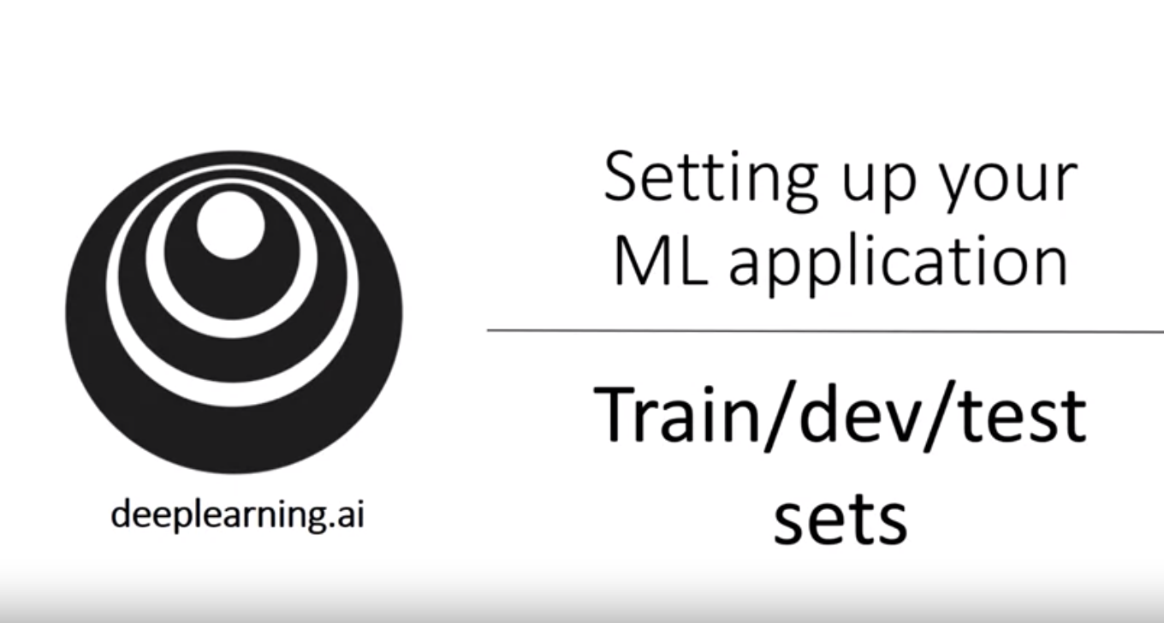

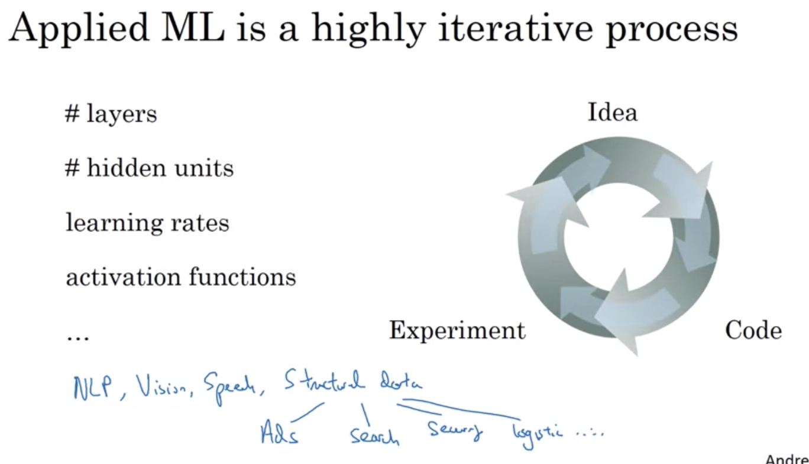

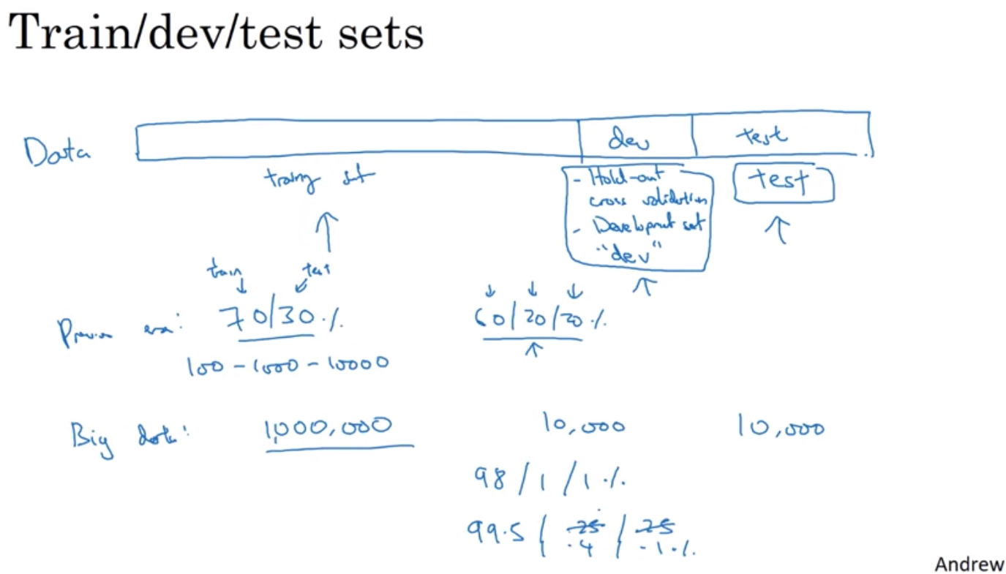

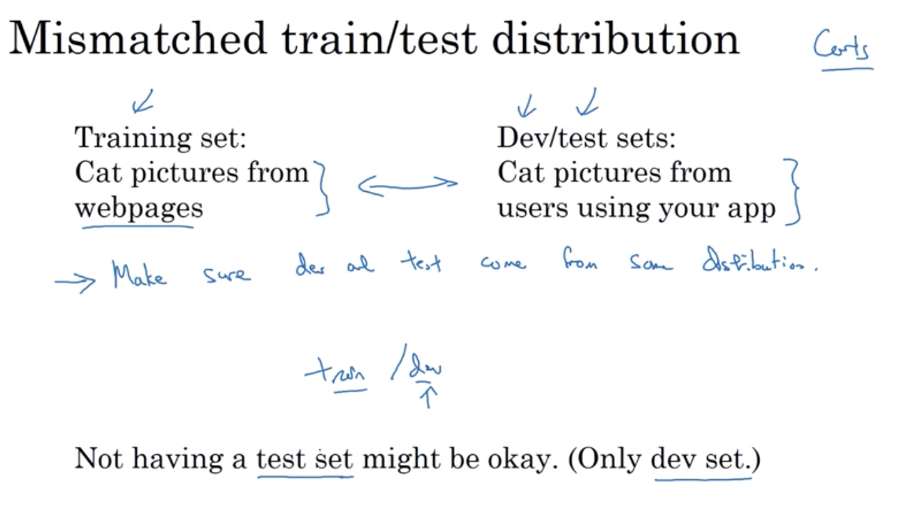

Bias vs. Variance

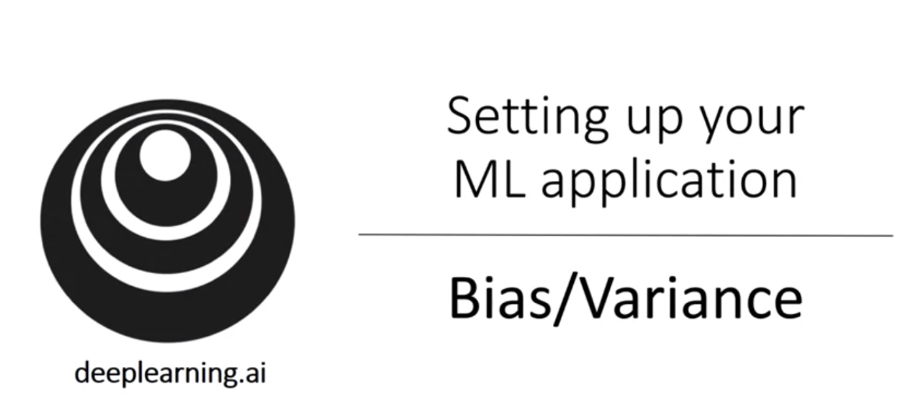

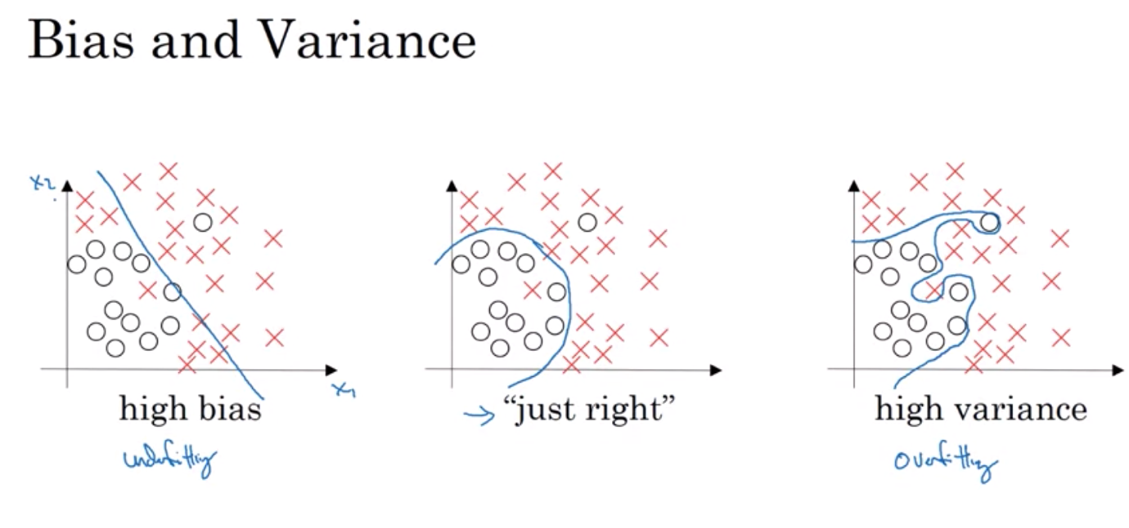

1st example: linear => not a good fit for the data => high bias => underfitting the data

3rd example: complex classifier => fit perfectly => high variance => overfitting

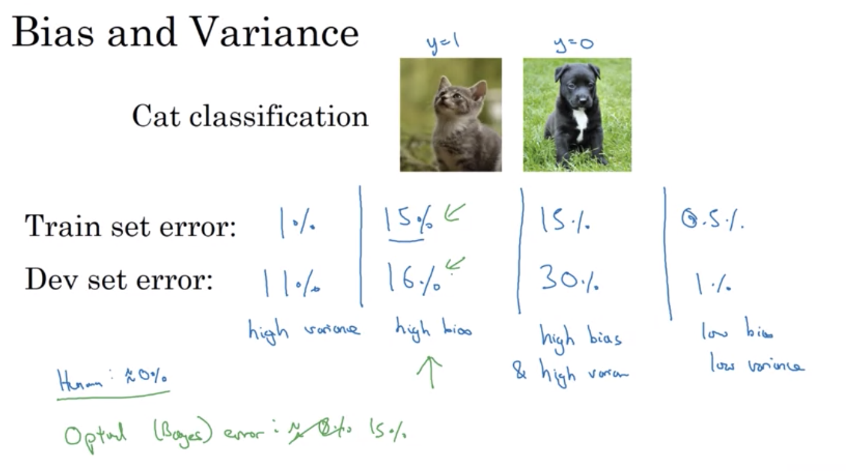

Bias and variance: based on assumption (base case) that optimal (bayes) error for human accuracy error: 0%

By looking at Training set error => understand how well you are fitting => tells if you have a bias problem

Then looking at how higher the error goes from training set to dev set => tells if you have a variance problem (how well can you generalize from the training set to dev set)

Assumption: base error is quite small and training and dev sets are drawn from same distribution

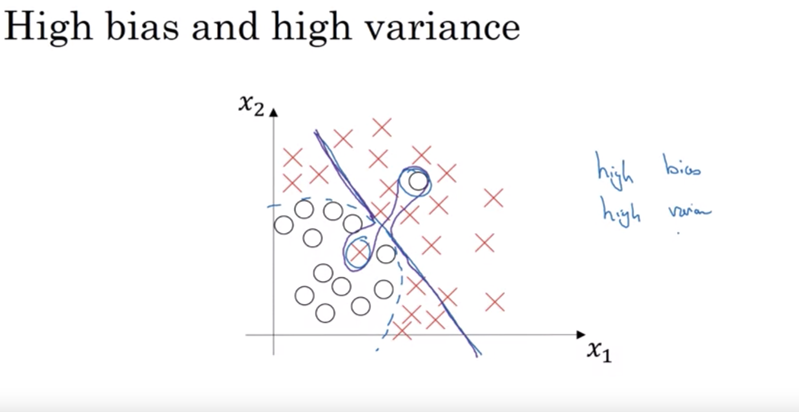

Basic recipe for Machine learning

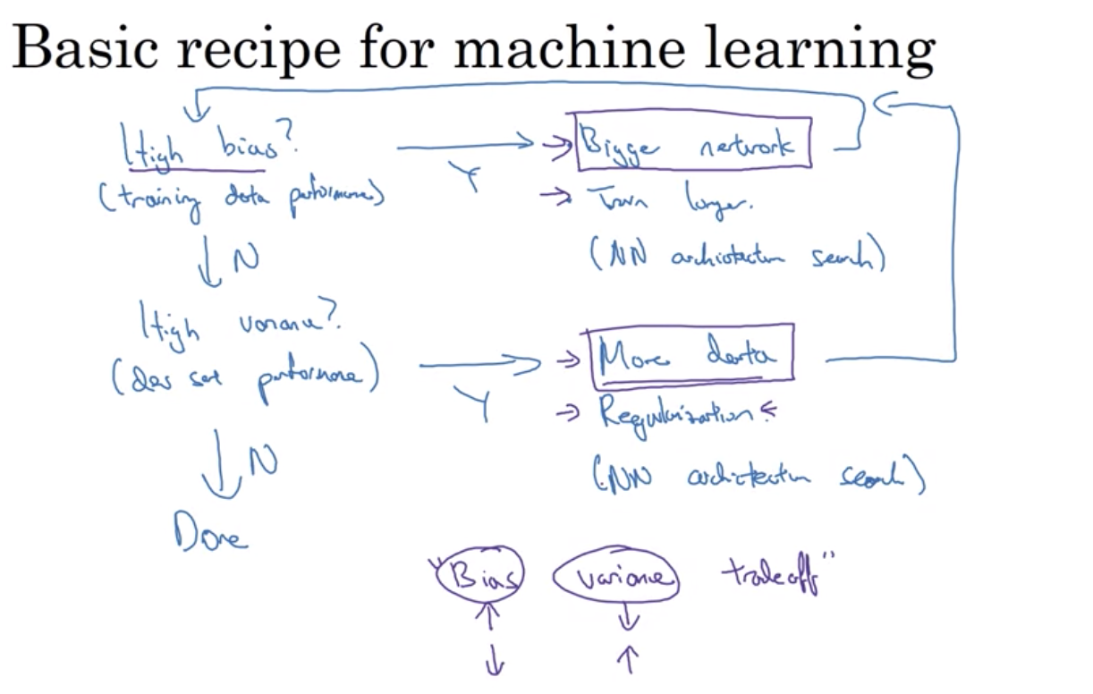

If you have high bias problem, have more data is not going to help

Pre Deep Learning era: there’s a bias-variance trade off where you can’t reduce one problem without increasing the other. But with Deep Learning, you can have more data to reduce variance problem without sacrificing bias, and vice versa, have bigger network to reduce bias problem without reducing variance.

* Why Deep Learning is such an useful supervised learning tool => have more options to keep balance between bias and tradeoff

REGULARIZATION

A technique to increase variance

* If you have a high variance problem => first thing is use regularization
* Can’t always get more data (expensive). Adding regularization => prevent overfitting, reduce errors in the neural network

Math:

* In cost function, add lambda/2m times the norm of w squared
* Why just regularize w and not b? w is usually high dimensional vector which might contribute to our high variance problem (w has lots of parameters and your model is not fitting all these parameters well enough) whereas b is just a single number => almost all parameters are in w so if we add in lambda b, it won’t make much difference as it’s just one parameter in a lot of parameters
* L1 regularization: w will be sparse (lots of 0 in it) => might help to reduce the dimensionality of the data/simplify/compress the data, less memory to store the model. But in practice, not that much?

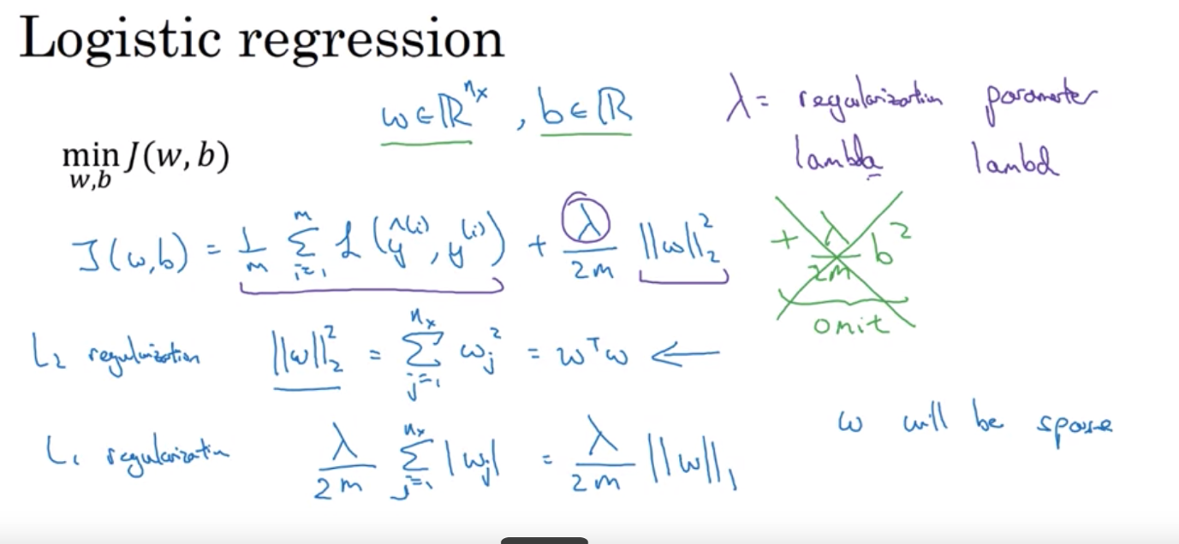

Regularization for Neural Network

Weight decay: w times something that is < 1

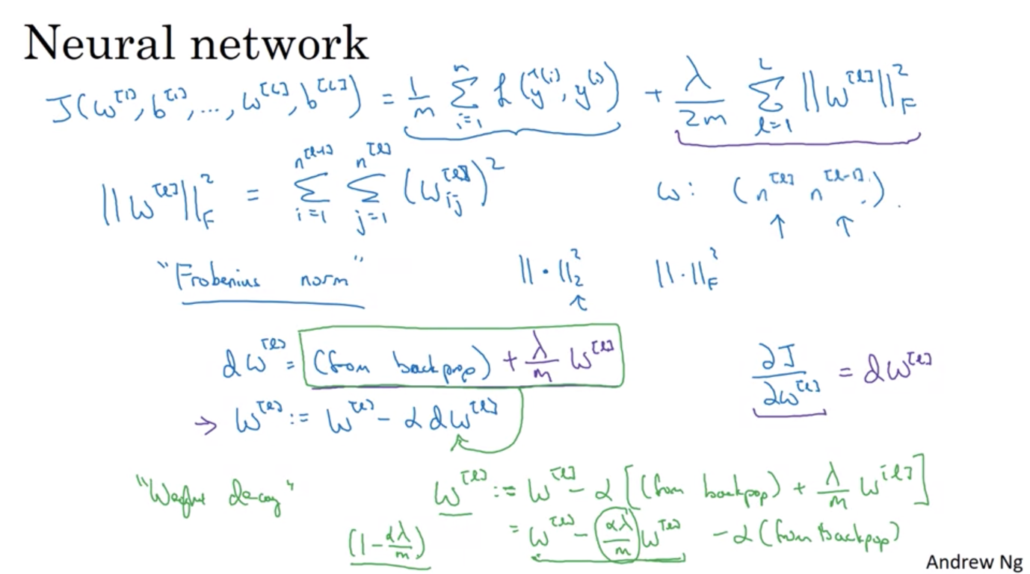

Why regularization prevents overfitting?

Regularization term penalizes the weight matrices from being too large

If you crank regularization lambda to be really big => weight is essentially close to 0 => take out some effectiveness of nodes/reduce impact of hidden units in neural networks => becomes a smaller/simpler neural networks => smaller chance of overfitting => move from overfitting to high bias case

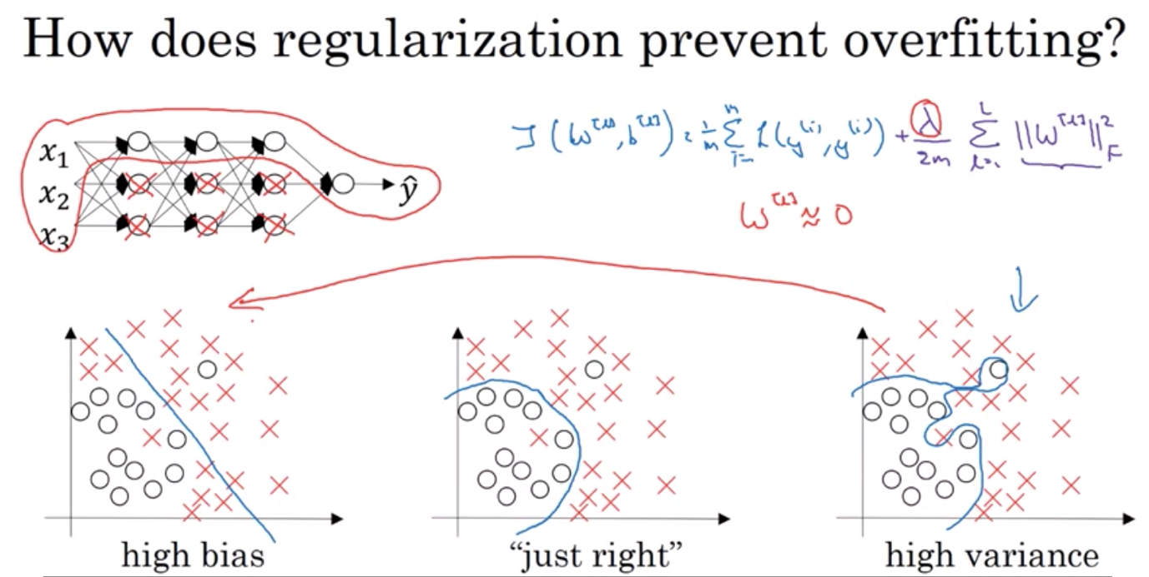

Another case: tanh function

If z is small, you only use the linear part of the function. Only after z wanders to larger value that it uses part of the function that is not linear

Same idea: if we add lambda that is sufficiently large => w is small => z is small => only use linear part => even a deep neural networks with linear activation function is only able to fit linearly => not able to fit the complicated path/non-linear decision boundaries that allow it to overfit the dataset

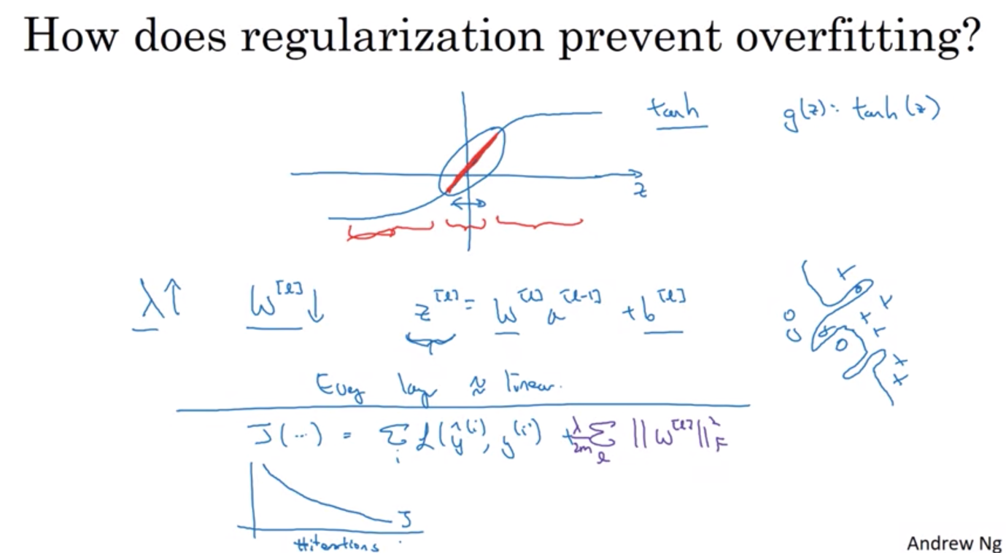

To debug gradient descent and see the decrease in gradient descent, include the lambda part in the cost function J as well.

DROPOUT REGULARIZATION

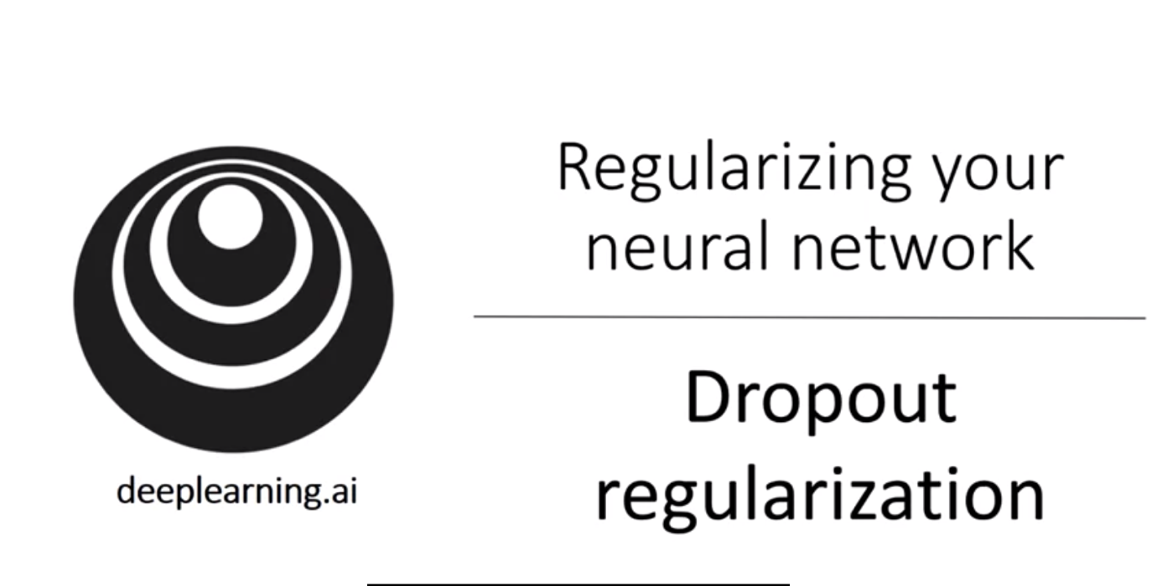

With dropout:

* Go through each layer of the neural network and set some probability of eliminating a node in neural network => delete some => end up with a smaller neural net
* For each training example, toss the coin again and reduce the neural net => train that example with that diminished neural net

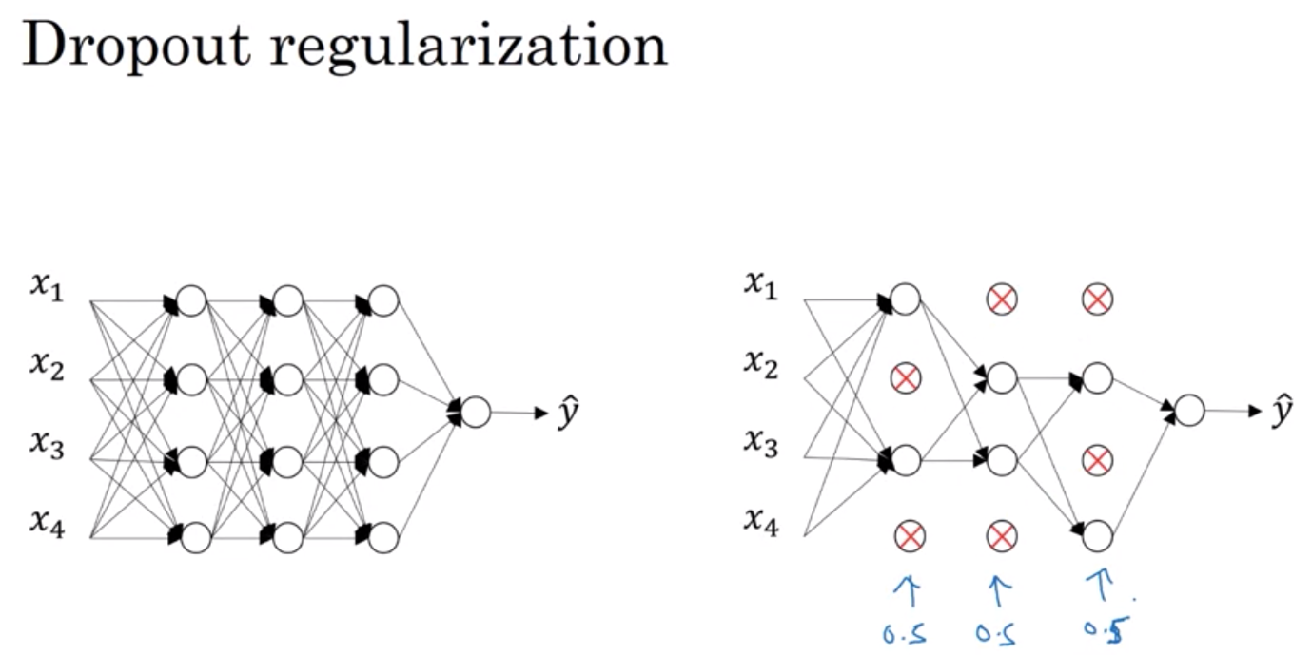

How to implement dropout?

3 ways to implement drop out:

* Most common: Inverted Dropout
* When making prediction, don’t use dropout => that would add noise to the result

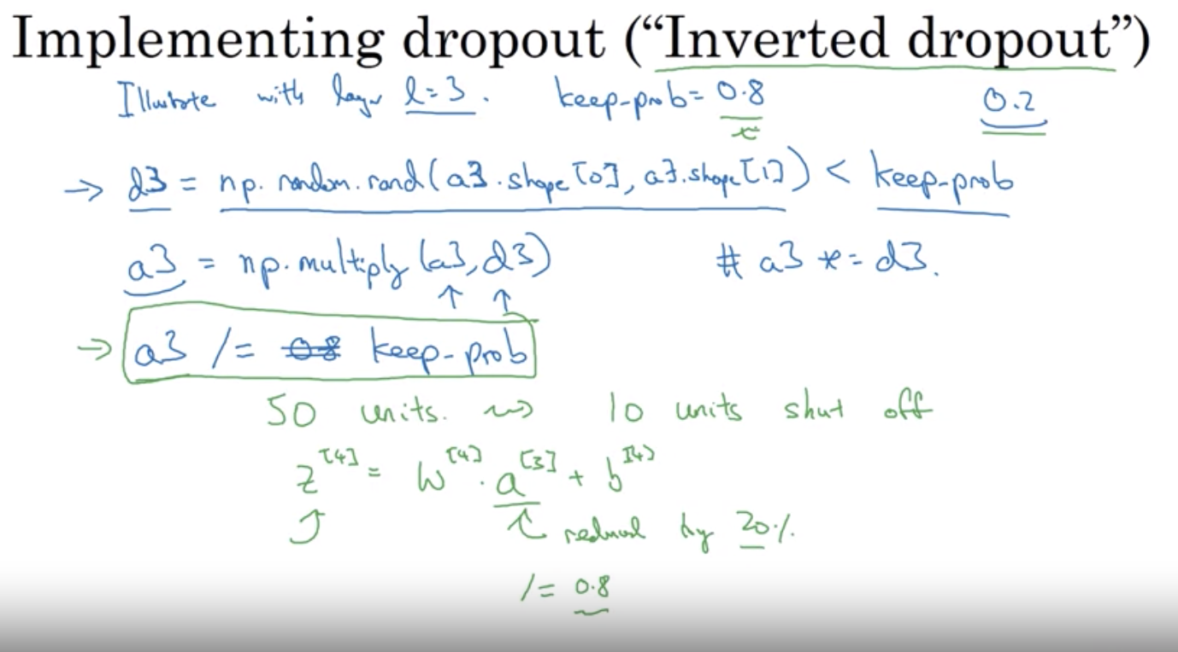

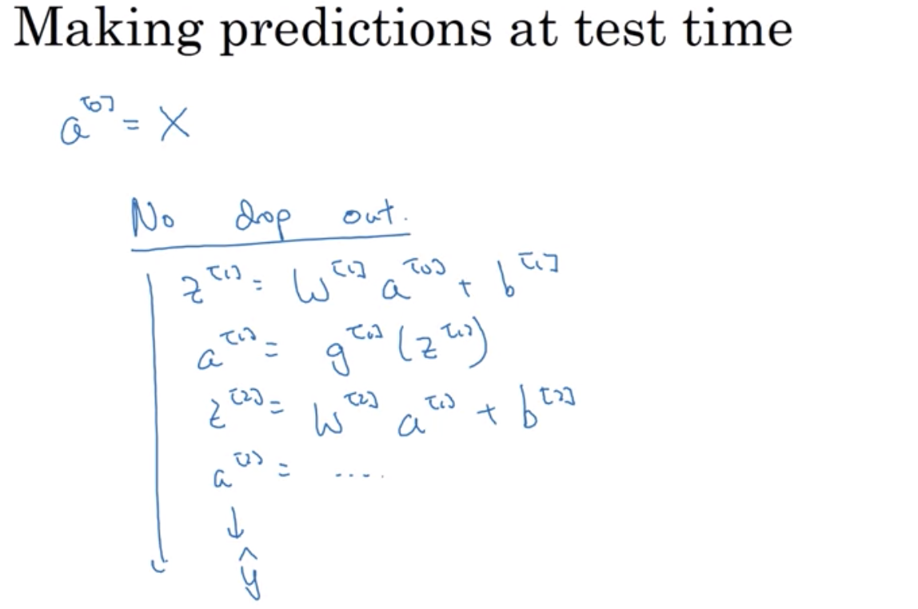

Why Dropout works?

The weights can’t rely on just one input => the unit will be more motivated to spread out to give the weight to each of the four inputs to this unit => have the effect of shrinking the squared norm of the weights => similar to the effect of L2 regularization => adjust the weights => an adaptive form of regularization but L2 penalty on different weights are different depending on the size of the activations being multiplied

For multiple layers, can vary keep_prob by layers: for layers that you worry about overfitting (the ones with lots of parameters), you can decrease the keep_prob value for a more powerful form of dropout => more hyperparameters to search for using cross-validation

* Maybe dropout for certain layers and others left untouched so less hyperparameters to take care of

Dropout:

* Usually used in Computer Vision: have to input all these pixels that you almost never have enough data for => almost always overfitting
* For others: only if you have the issue of overfitting, use regularization

Downside: cost function J is no longer well-defined. On every interation, you’re randomly killing off a bunch of nodes => harder to double check the performance of gradient descent

* What to do: turn off dropout, run code and see if the model is monotonically decreasing J and then introduce dropout (and hope that there’s no bug during dropout)

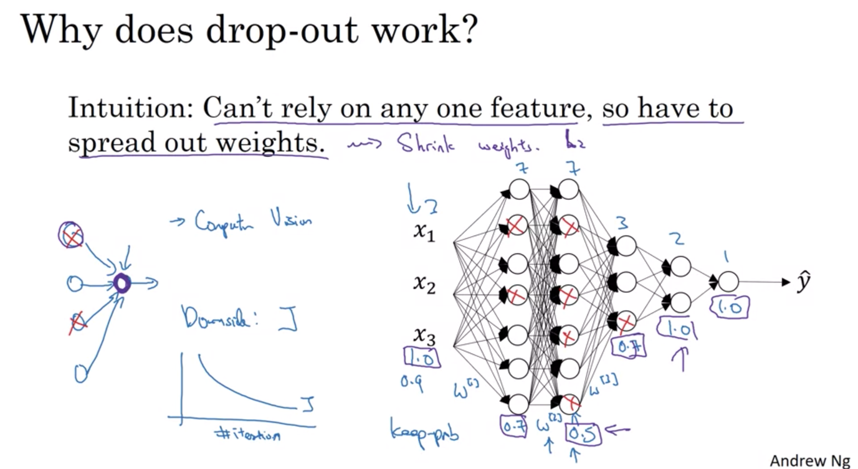

Other Regularization technique:

* Data Augmentation: Data collection sometimes is expensive: use data augmentation (random distortion of the images) => inexpensive way to increase dataset => sort of regularize it and reduce overfitting
* Early stopping: find the sweet spot for training and dev set error => by stopping midway, you have a mid-size w, which is like L2 regularization, helps your model to overfit less. Problem:

Usually in Machine learning, it’s better to think of Orthogonality: separate tasks: Optimizing the cost function and Trying not to overfit, but early stopping break that procedure as you’re trying to do 2 things at the same time => sometimes L2 Regularization is better (although it’s computationally more expensive as you have to search for many lambda hyperparameters). Early stopping can help you reach there faster as you only have to run once and trying out small/large/midsize w.

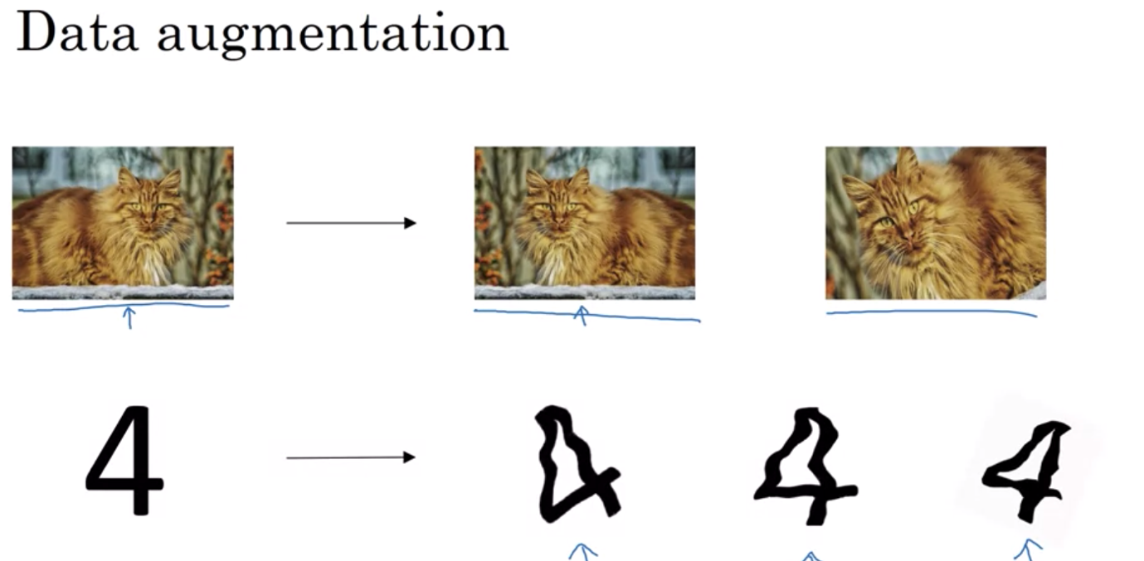

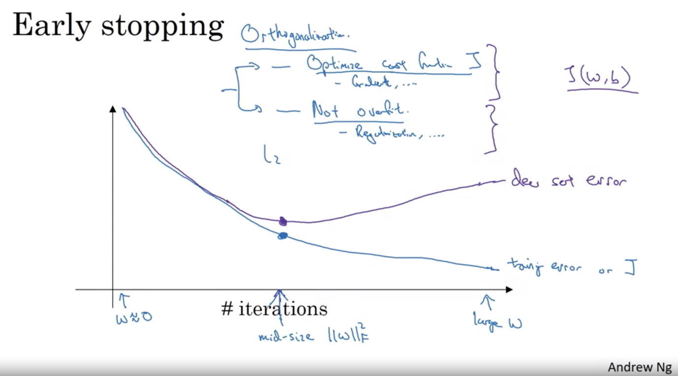

SETTING UP OPTIMIZATION PROBLEM: to help your training go quickly

NORMALIZE INPUTS

Why normalize: with normalization, the cost function will look more symmetric => easier for gradient descent to find the minima => it’s easier for your model to fit when the variables are of similar scale

Lesson: if your features are in vastly differing scales (0-1 vs. 1-1000) then it’s better to normalize. If your features come in on similar scales => this step is less important

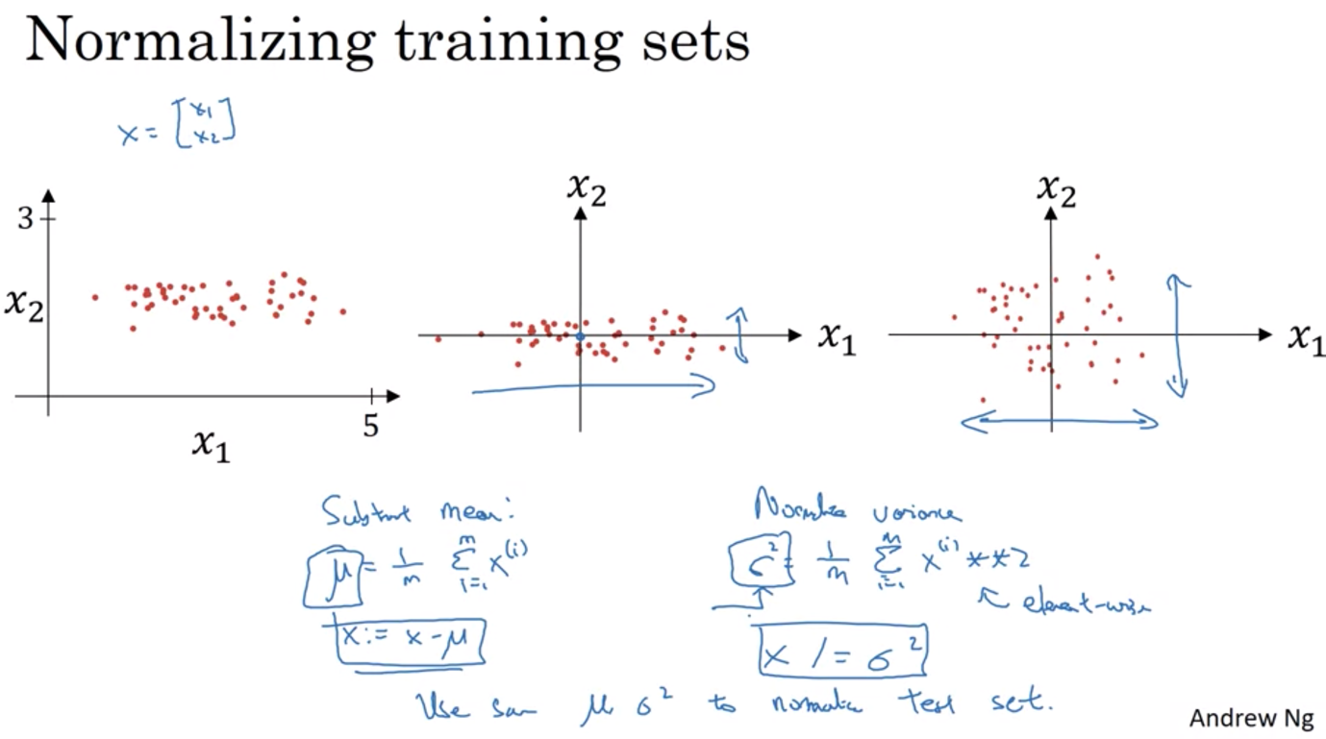

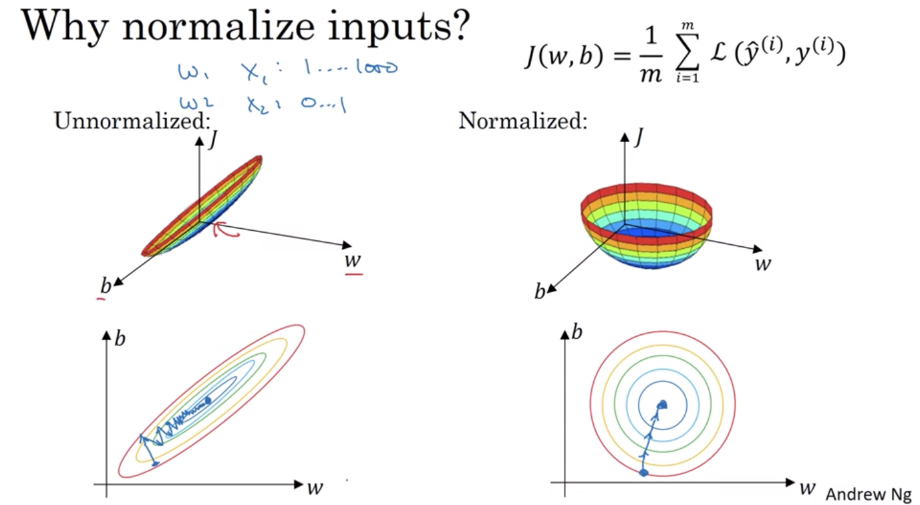

VANISHING/EXPLODING GRADIENT

Sometimes, the slope of the gradient will be either very very small or very very big => learn how to reduce this problem with random weight initialization

If the weight is just a little bit bigger than the identity matrix then there’s high potential for a very deep neural network activation to explode exponentially. If the weight is just a little smaller than I, then activation might decrease expotentially.

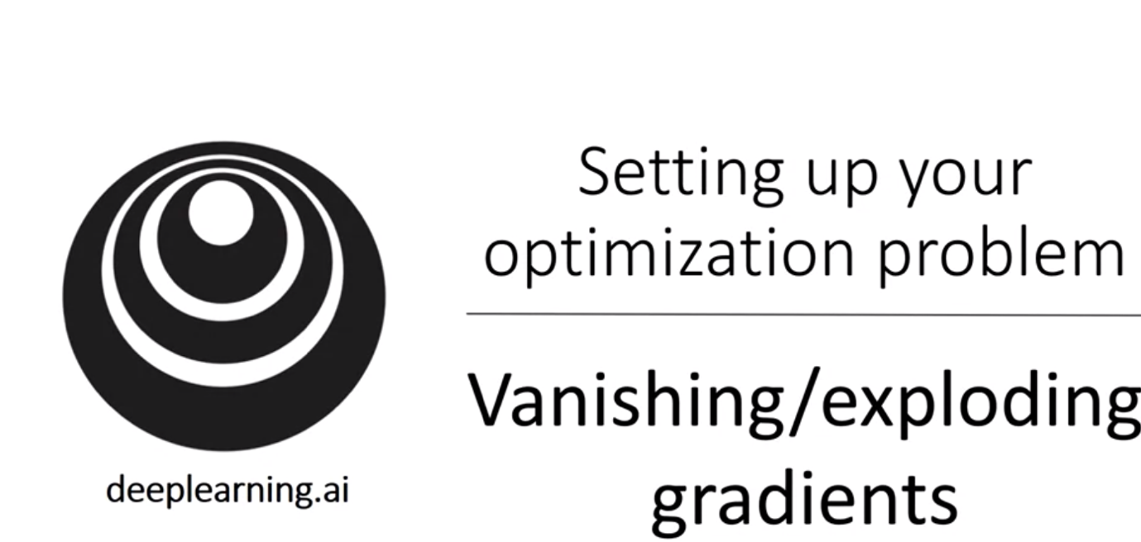

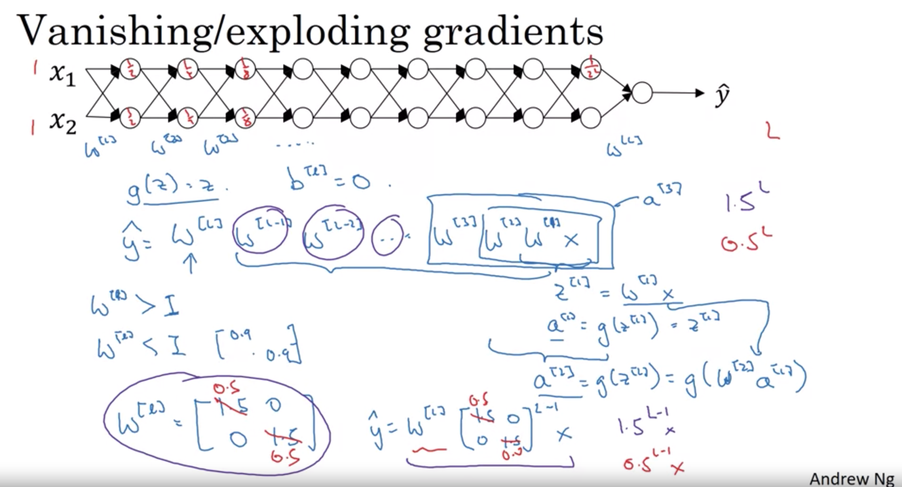

SOLUTION: Carefully initialize the weight helps partially solve this

Set w in a way that is not too much smaller or larger than 1 so that it doesn’t explode.

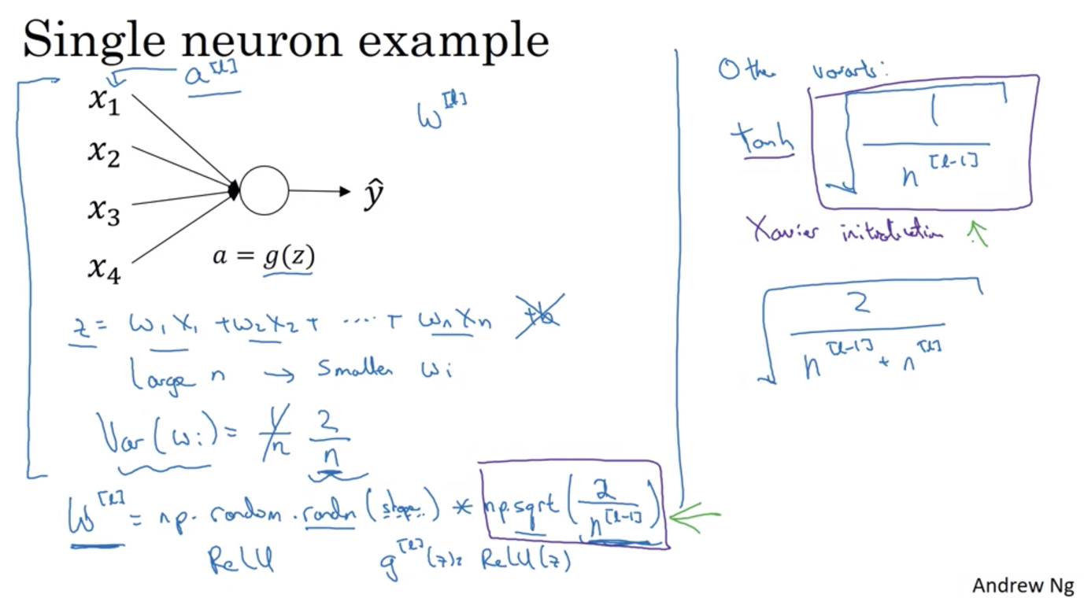

Numerical approximation of gradient: Gradient checking

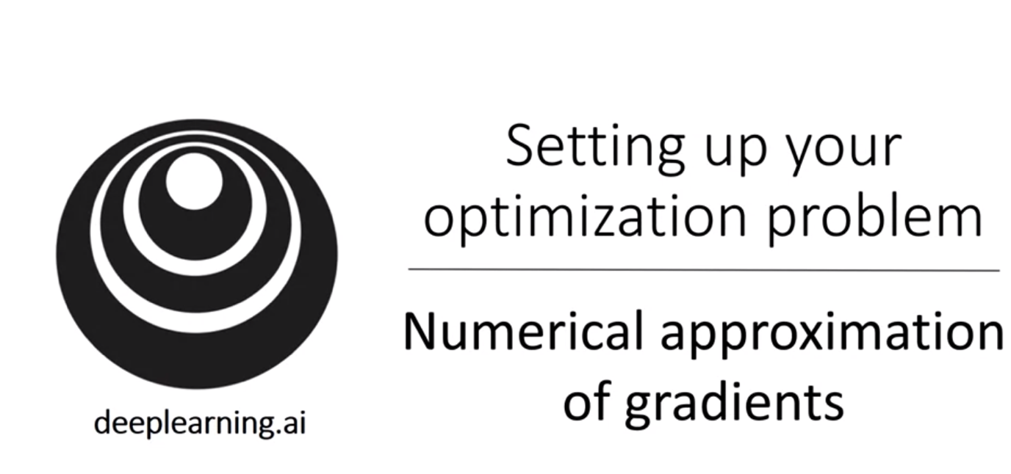

Use 2 side approximation to get slope of function at theta :

* Using two sides, the error is on the order of epsilon square, which with a number lower than 1 is actually much less than the error with 1 side => compute the gradient more accurately

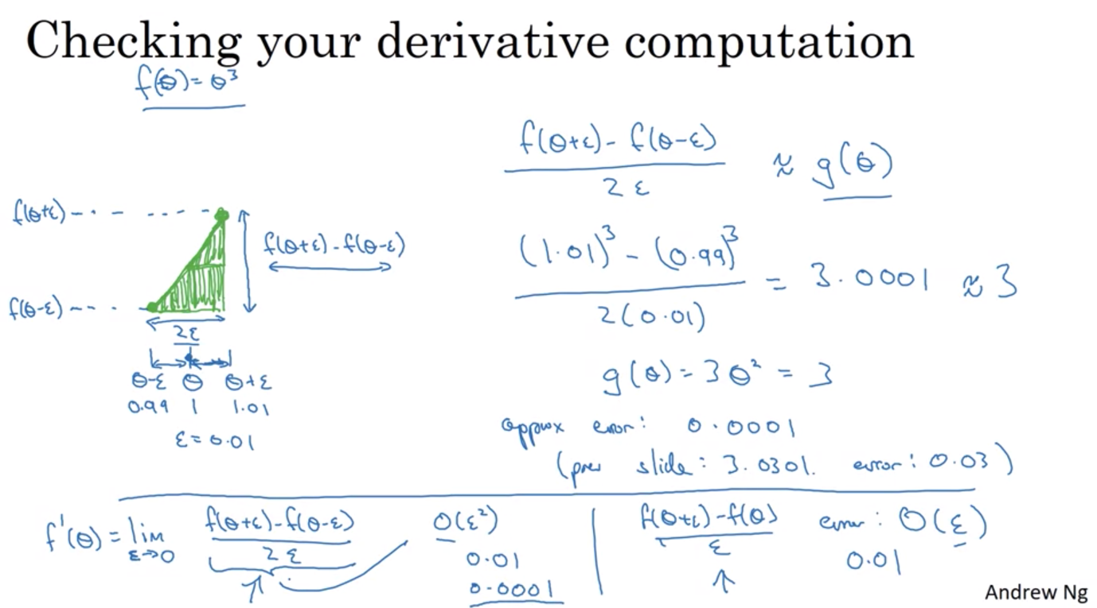

GRADIENT CHECKING: helps to find bugs in back propagation

Use epsilon = 10^-7. If the ratio is also <= 10^-7 => that’s great, approximation is correct

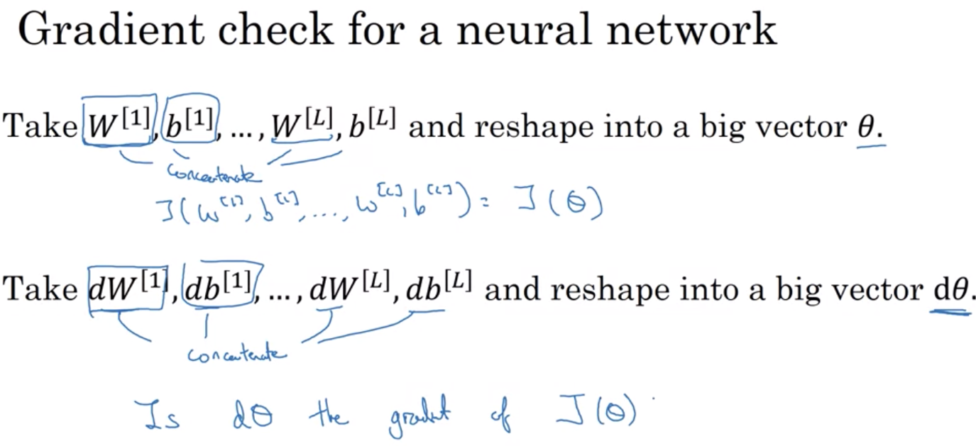

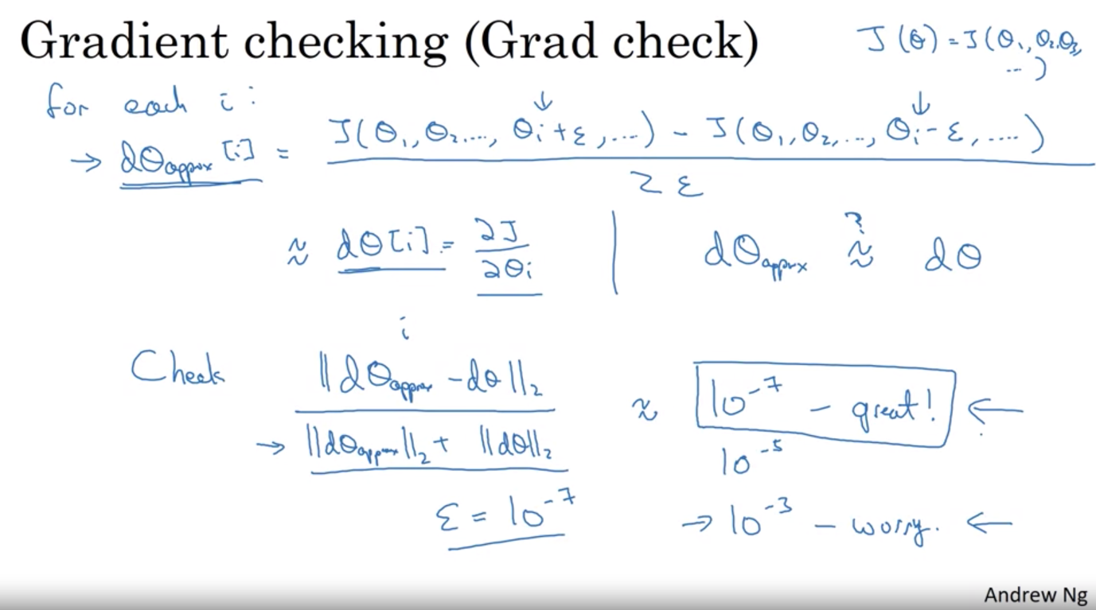

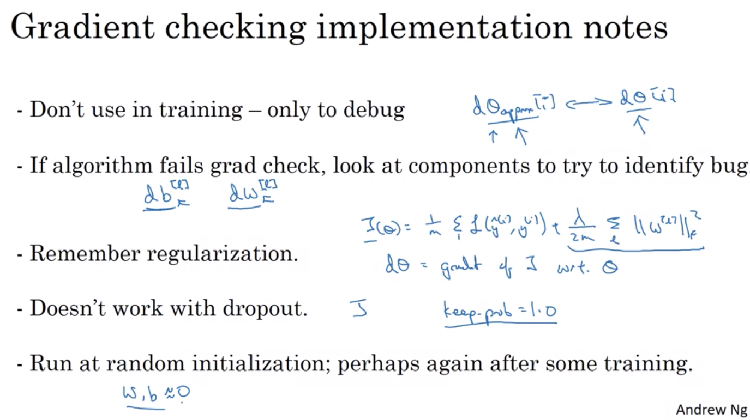

WEEK 2 – OPTIMIZATION ALGORITHM

Mini Batch Gradient Descent

Vectorization allows you to efficiently compute on all m examples

* But what if m is too large?
* Split training set into baby training sets called mini-batches and process them concurrently

Mini Batch runs much faster than batch and is what is used in deep learning

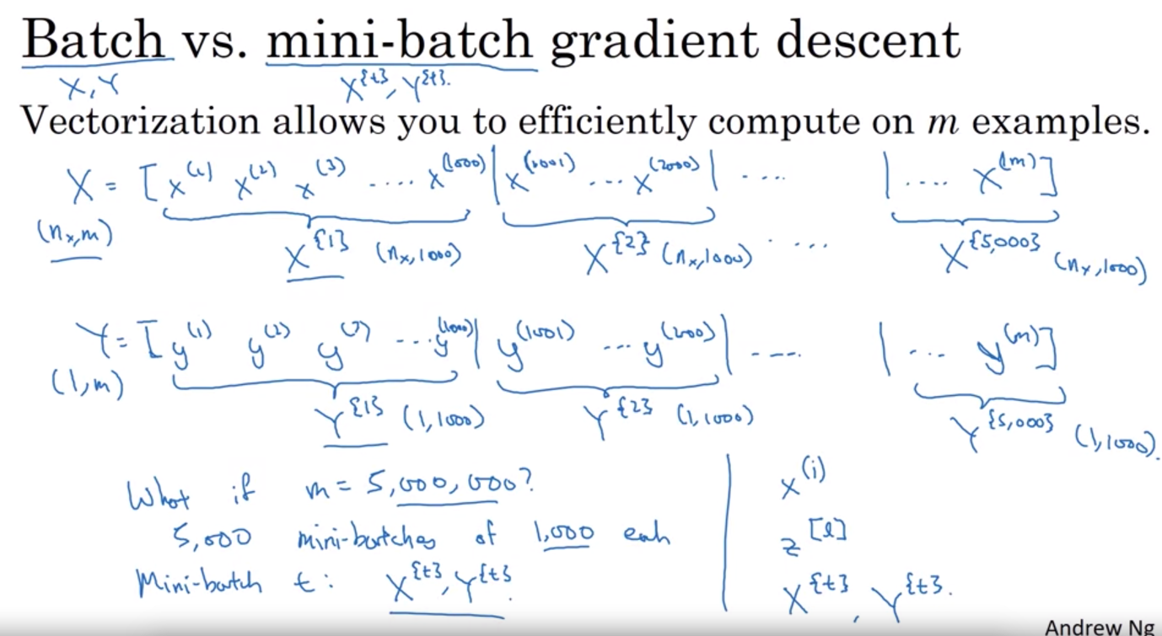

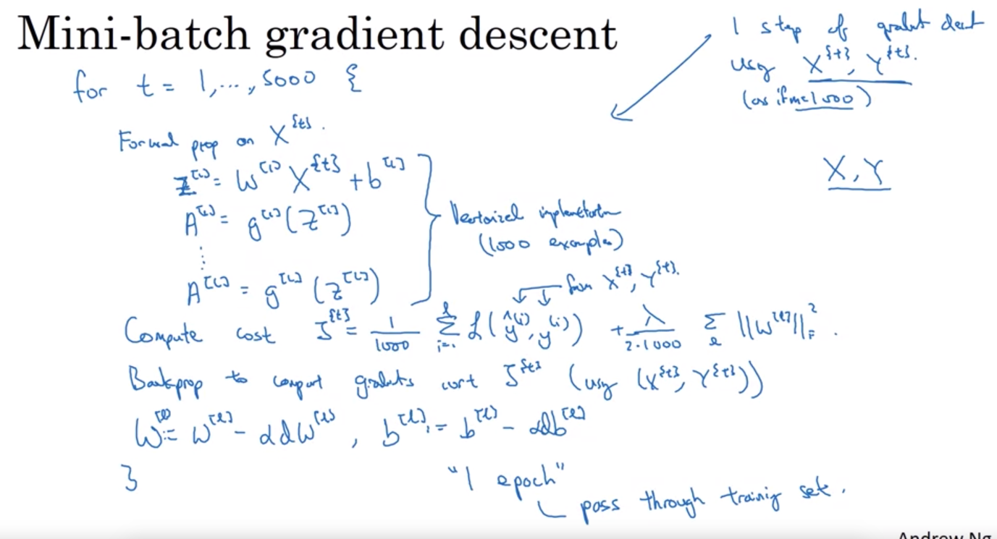

Understanding mini-batch gradient descent

* With batch gradient descent: cost function J goes down with every iteration
* With mini batch: cost function J might not goes down every iteration as you’re training on a different set of batch every iteration. The trend would still be downward but it is much noisier

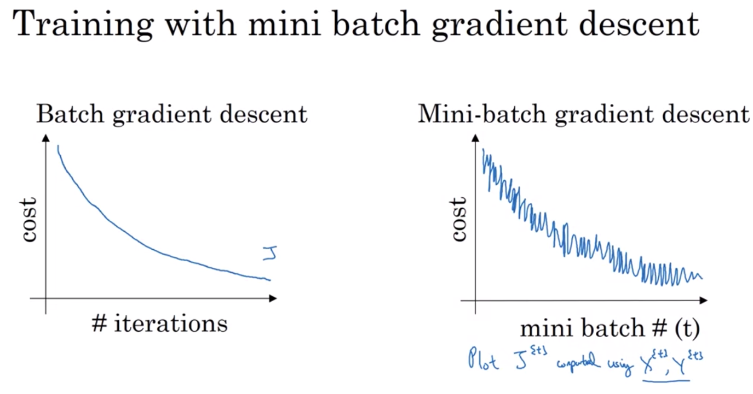

Choose mini batch size:

* Batch gradient descent: able to take relatively low noise and large step => gradually marching towards the minimum
* Stochastic gradient descent: start somewhere, but with each step, only train with 1 sample => small step, sometimes goes in the wrong direction => extremely noisy, on average takes you in the right direction but sometimes the wrong dir as well => never really converge but oscillate and wander around the region of the minimum => won’t ever just head to the minimum and stay there
* In practice, choose something in between the two : try out different possible batch size with power of 2

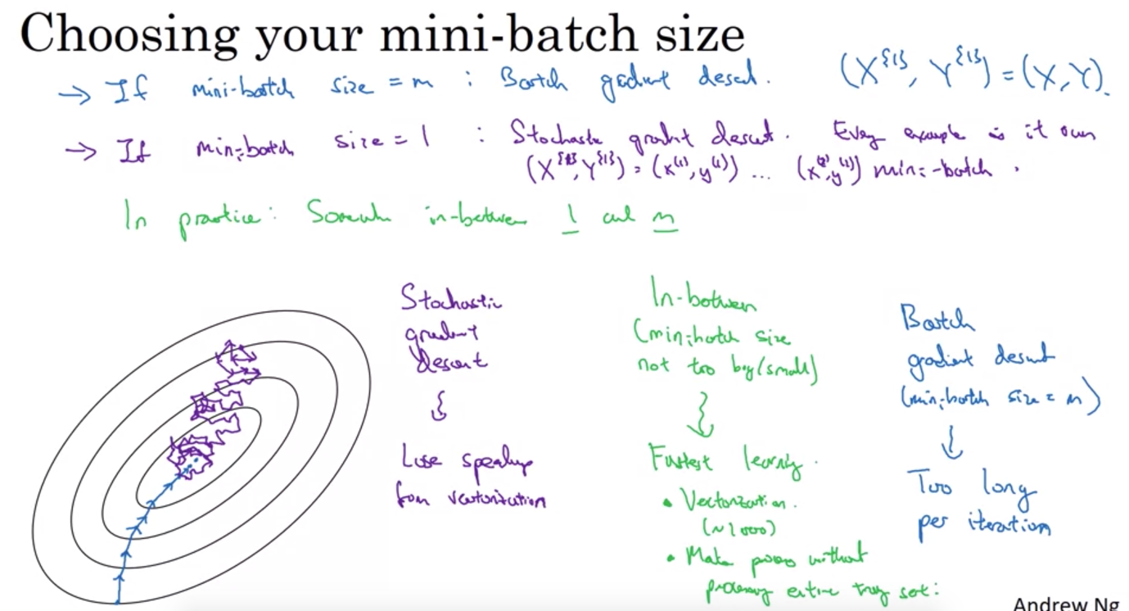

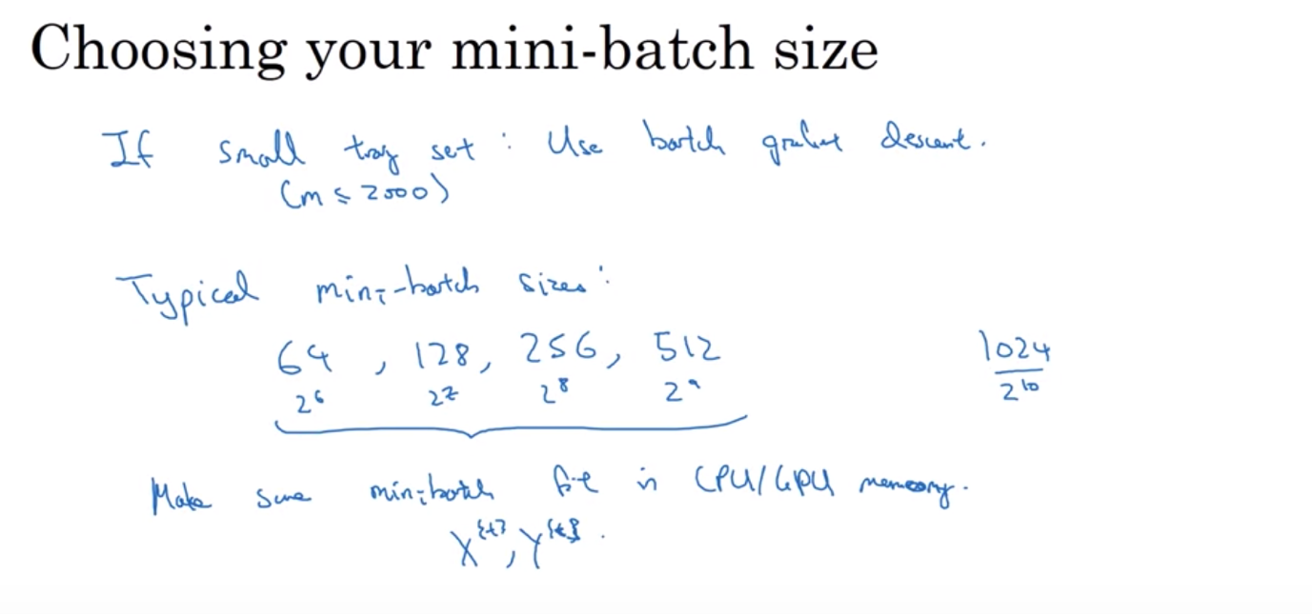

FASTER ALGORITHM THAN GRADIENT DESCENT:

EXPONENTIALLY WEIGHTED AVERAGES: exponentially weighted moving averages

If averaging over a larger window of days (50 vs. 10), the curve is smoother but slower to adapt to the changes => you give a lot of weights to the values before and less to what you see now => when there’s change in the temperature, the exponentially weighted averages adapt more slowly when beta is so large (meaning more days in the window)

If smaller window of days (2) => lots of noise and prone to outliers, very sensitive to changes

* By varying hyperparameters Beta, we can have different effects and find optimum

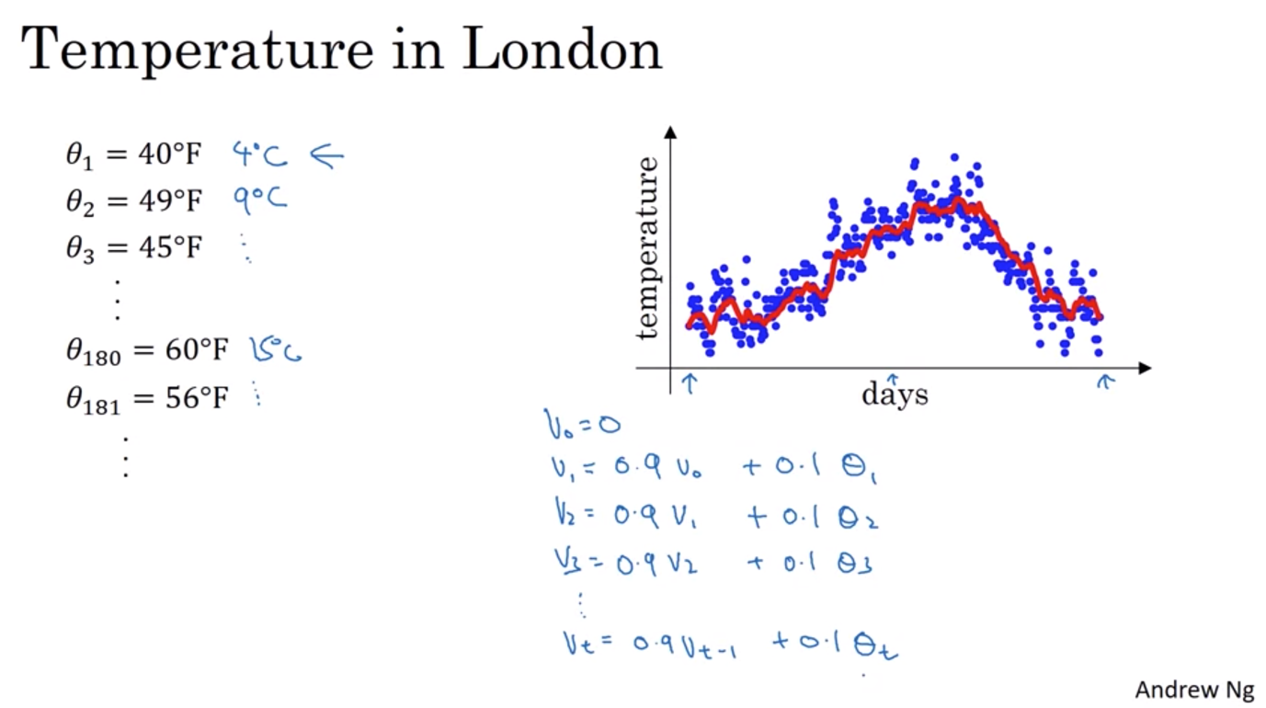

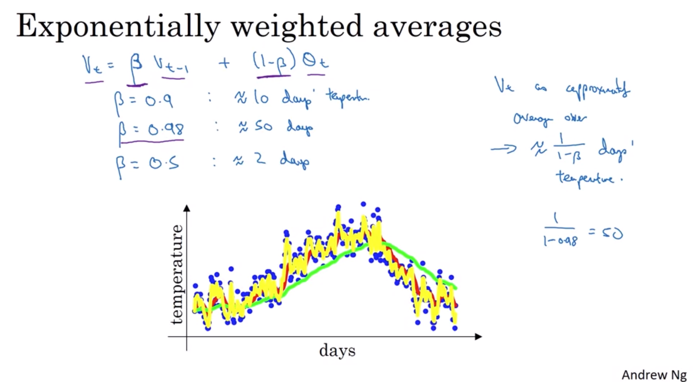

Intuition:

* It takes about 10 days for the height of v to decay by 1/3
* Exponentially weighted averages: inexpensive in time and space

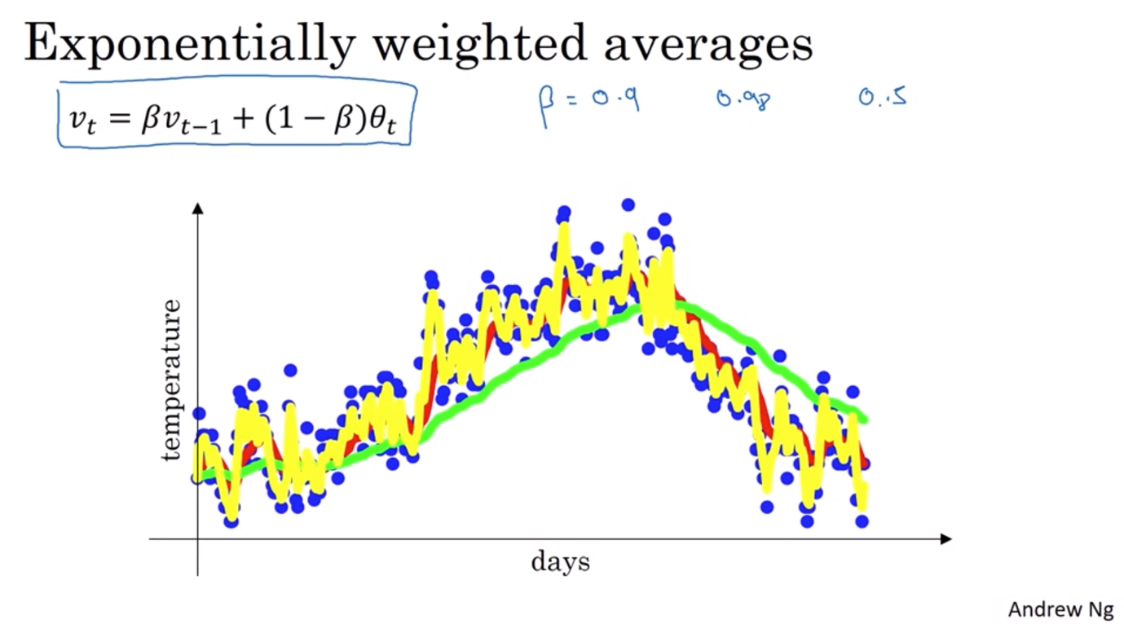

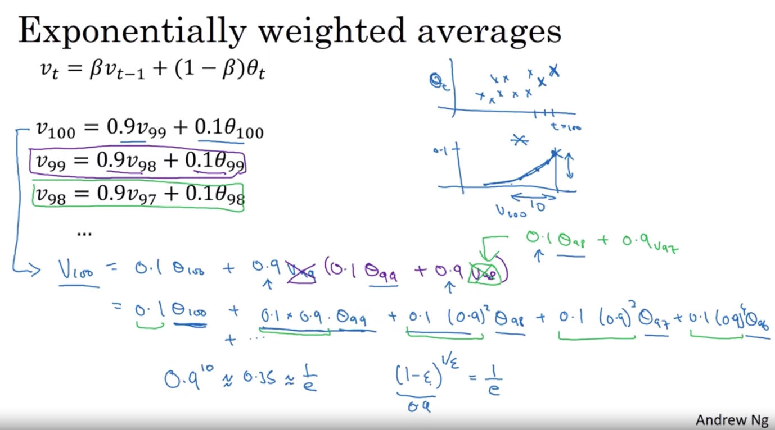

Bias Correction

Usually when you implement exponentially weighted average, the initial phase when the algorithm is warming up is quite biased => fix that by divide by (1-beta)

Often this is not really important but if you want to just keep the initial phase as close to good fit as possible, bias correction is the way to go

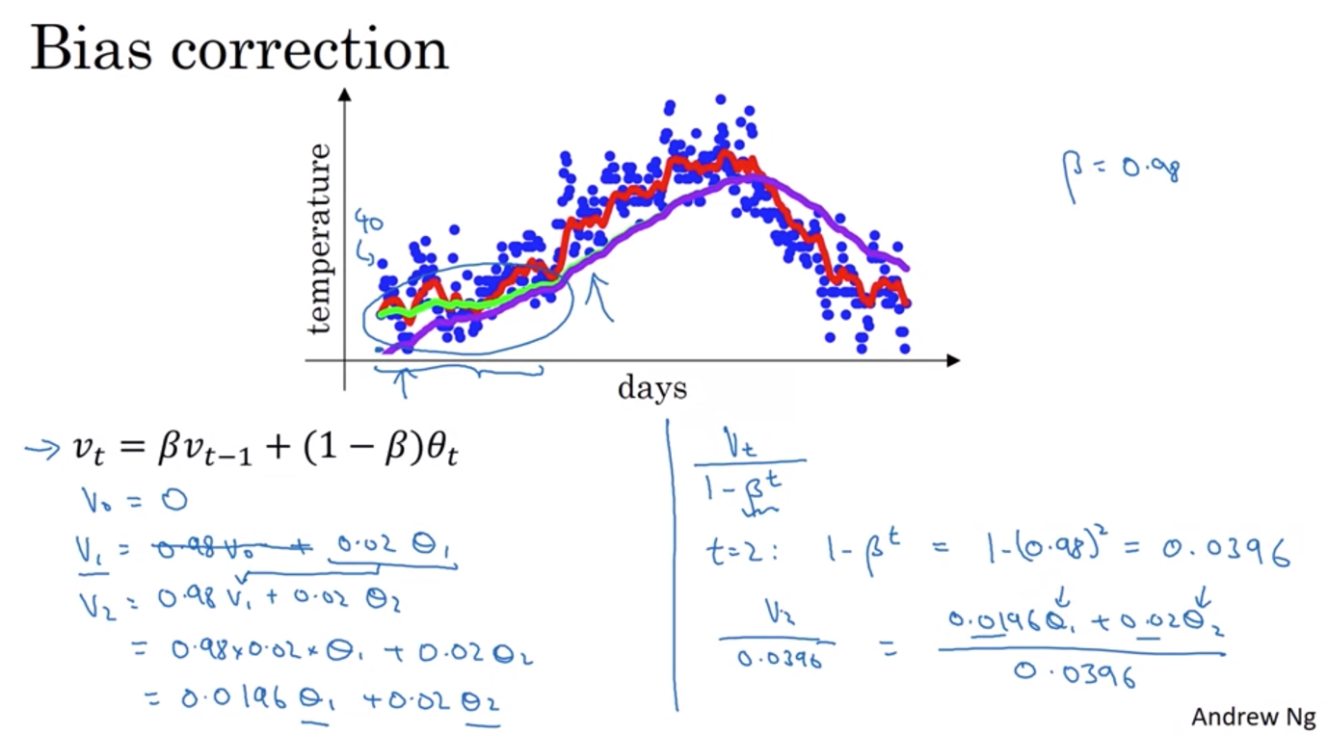

GRADIENT DESCENT WITH MOMENTUM:

Almost always run faster than usual gradient descent. Compute the exponentially weighted averages of your gradients and then use that to update your weights instead.

Gradient descent with mini batch: in contour map

* usually you oscillate to get to the minimum, if the learning rate is too large then you might overshoot
* also on vertical axis, you want learning rate to be slower to not overshoot but on horizontal axis, you want learning rate to be faster to get to the minimum

Gradient descent with momentum:

* on iteration t, after compute derivatives of the mini batch => compute the moving averages of the derivatives for w and b => then update the weight and error (b) with the new moving averages => smooth out the steps of gradient descent => takes fewer steps with much smaller oscillation => allow your algorithm to take a more straightforward path towards the minimum => a like ball rolling downhill with acceleration (push of momentum)

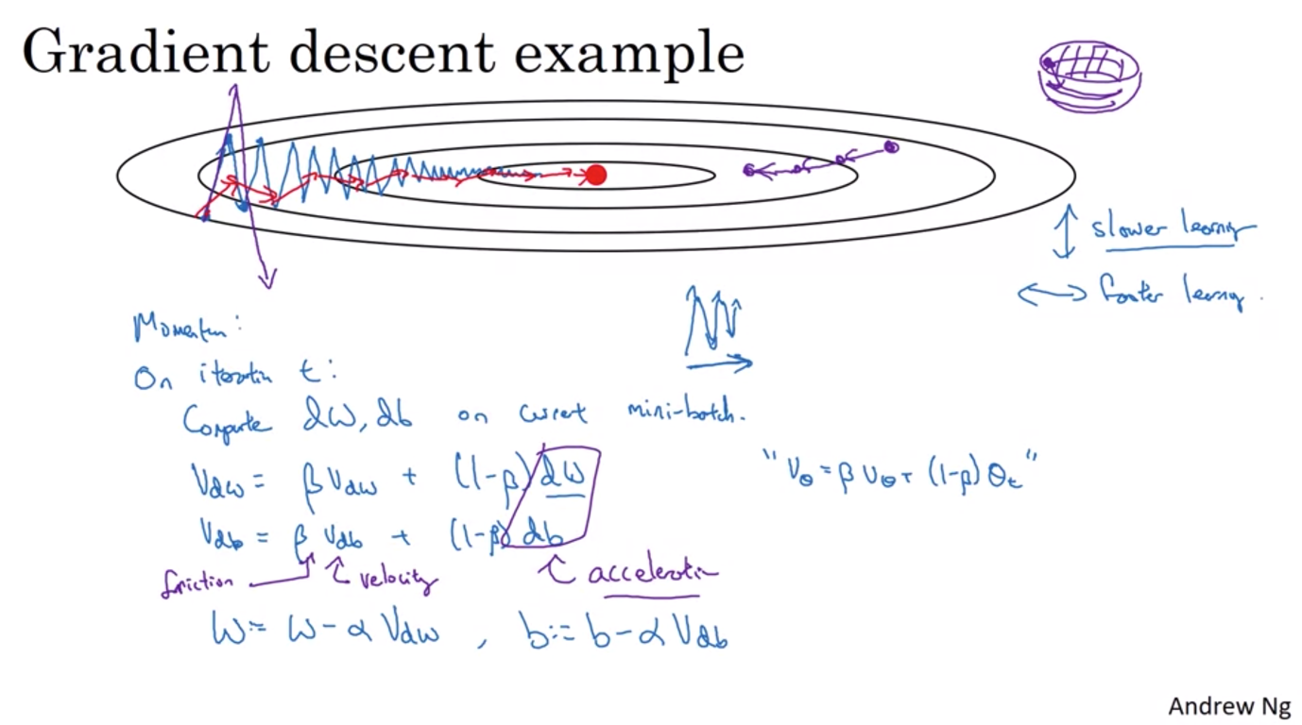

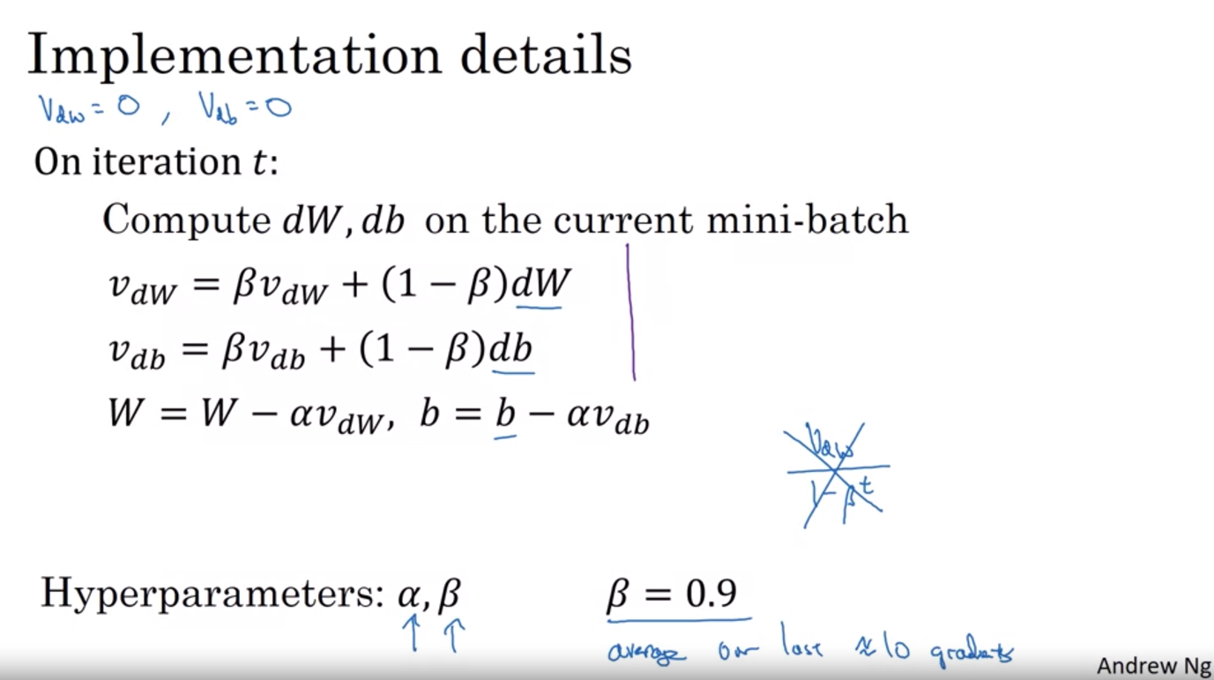

RMS Prop Algorithm: (root mean square prop) can also speed up gradient descent by damping out the effect of oscillation in the minibatches (like momentum) while allowing for higher learning rate

Same concept as trying to increase the horizontal step and decrease the noisy vertical oscillation => so can have faster learning rate

Later on will combine RMS prop with momentum

For numerical stability, add a small error term (epsilon = 10 hat -8) to make sure Sdb doesn’t go too small and make the gradient explode.

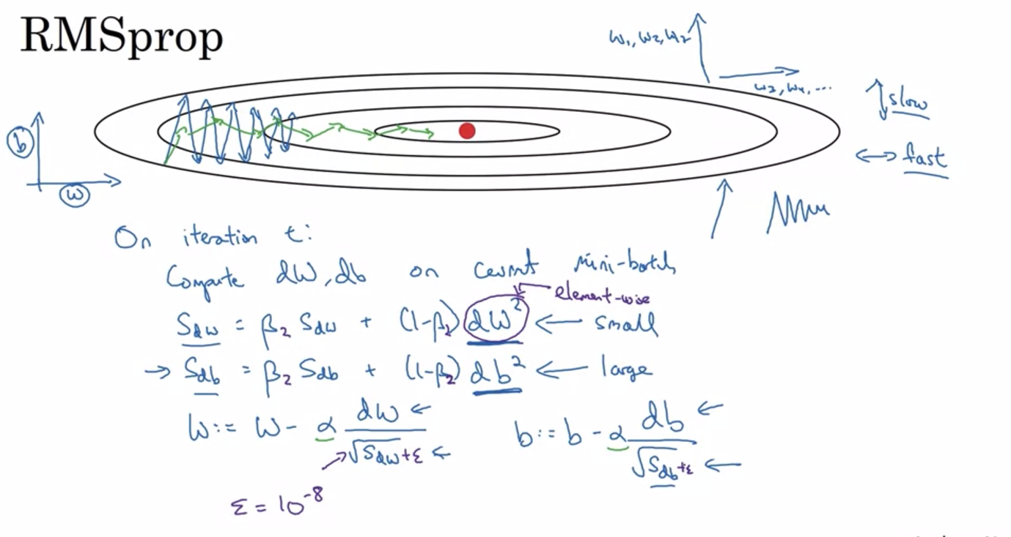

Adam Algorithm: combining RMS prop and momentum create an even more powerful algorithm

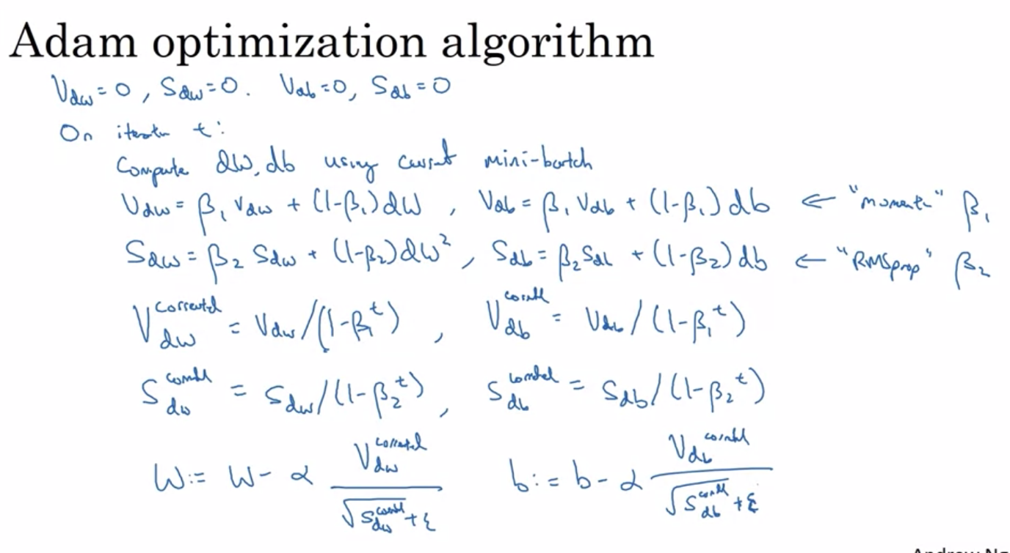

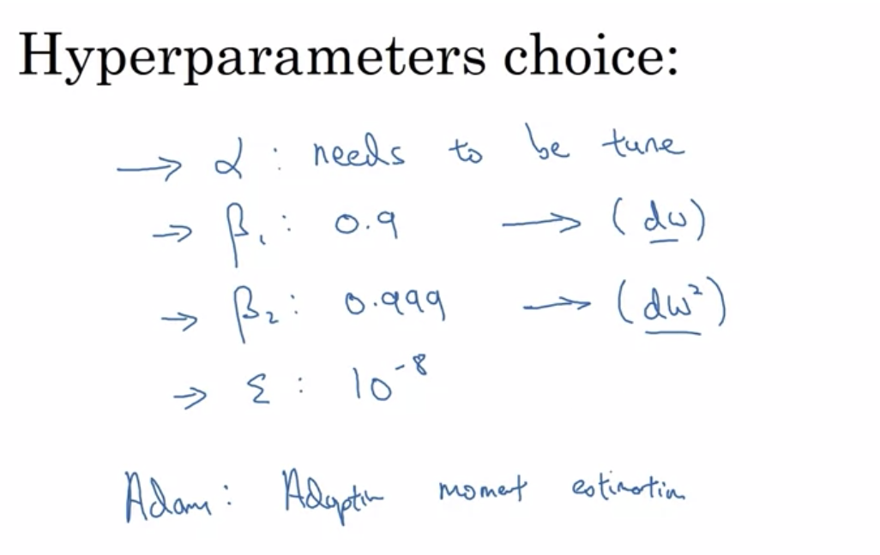

Learning rate decay

Mini batch decay: your algorithm doesn’t really converge with small mini batch and wander around the minimum if the learning rate alpha is fixed. However, if you slowly reduce alpha, in the intial phase, learning rate is still large so you take larger steps, but as you get closer to the minimum, you wander tighter around the minimum!

Tune: Initial learning rate & decay rate

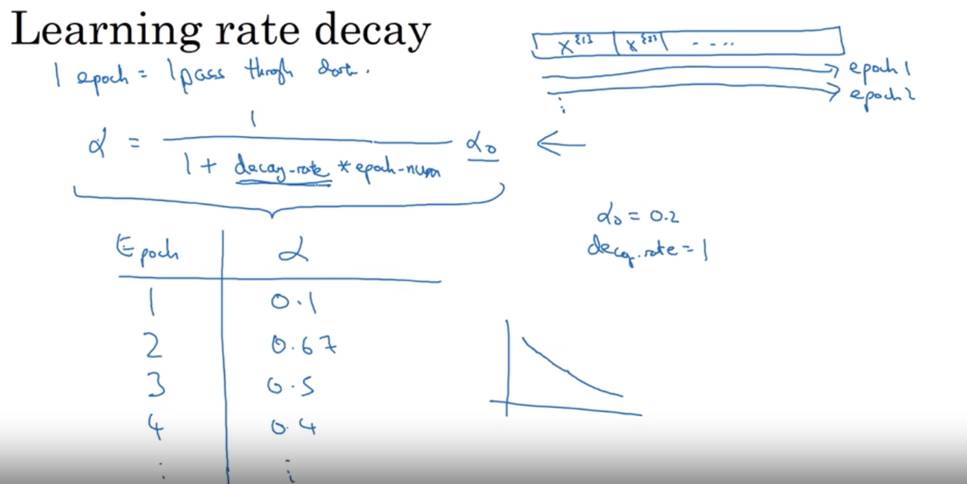

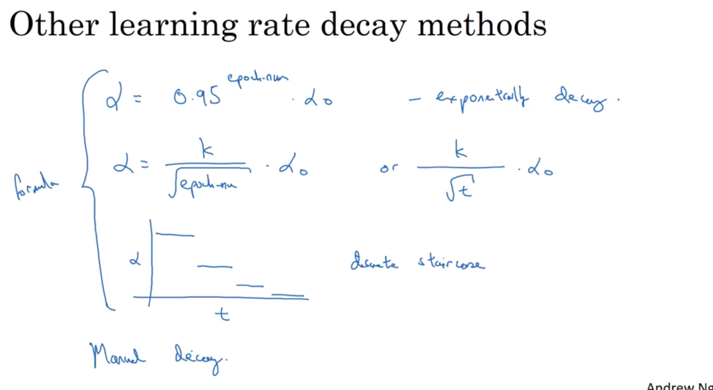

The Problem of Local Optima

In high dimension, you’re more likely to run into saddle point than local optimum

* problem of plateau :slowly move down the slope and then move down again in the saddle => that’s why RMS prop and Adam should be used to help speed up the learning

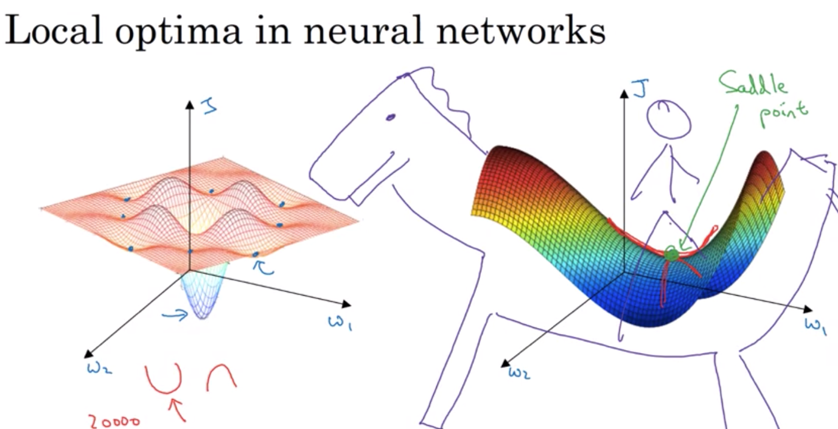

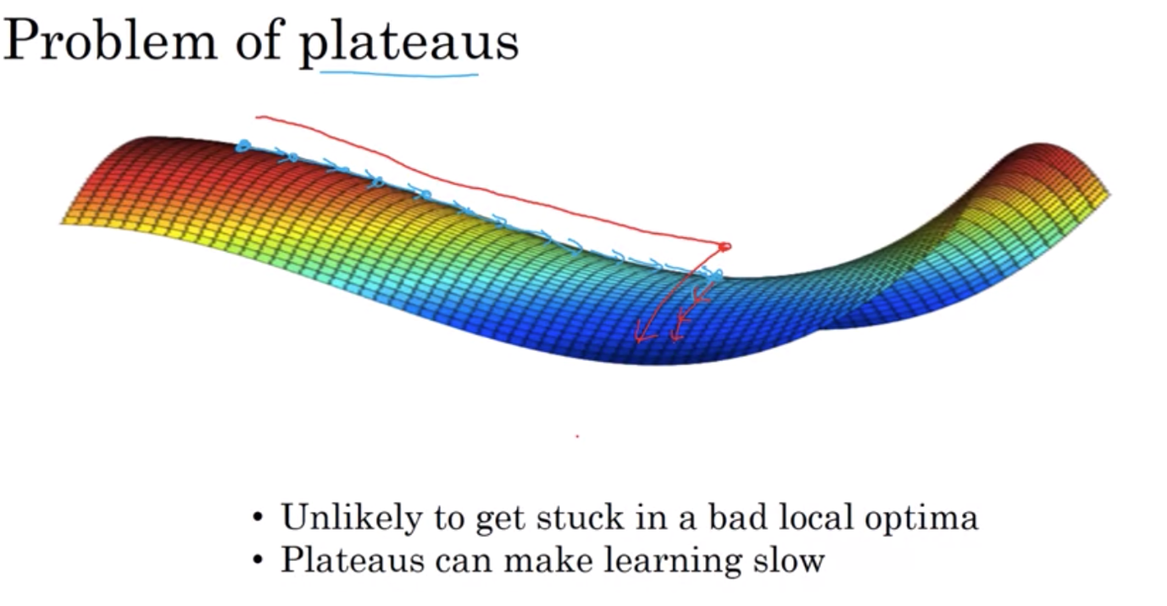

HYPERPARAMETER TUNING

Tuning process

* Learning rate alpha: most important to tune
* Momentum term: next most important
* Mini-batch size: making sure the optimization algo is running efficiently
* No of hidden units
* No of layers
* Learning rate decay
* For parameters of Adam, can just use default

Don’t use grid search but try out random values as some hyperparameters are more important than others => randomization ensures you get to try out different values for these important ones => explore more richly the values

Coarse to fine searching: if you come across a hyperparameter that works well, the best one might be hidden around it somewhere => randomized in a particular region.

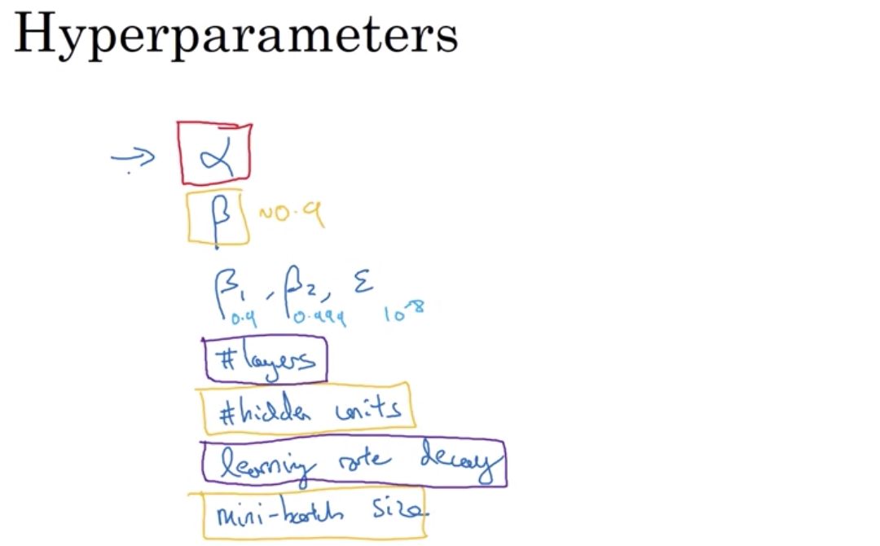

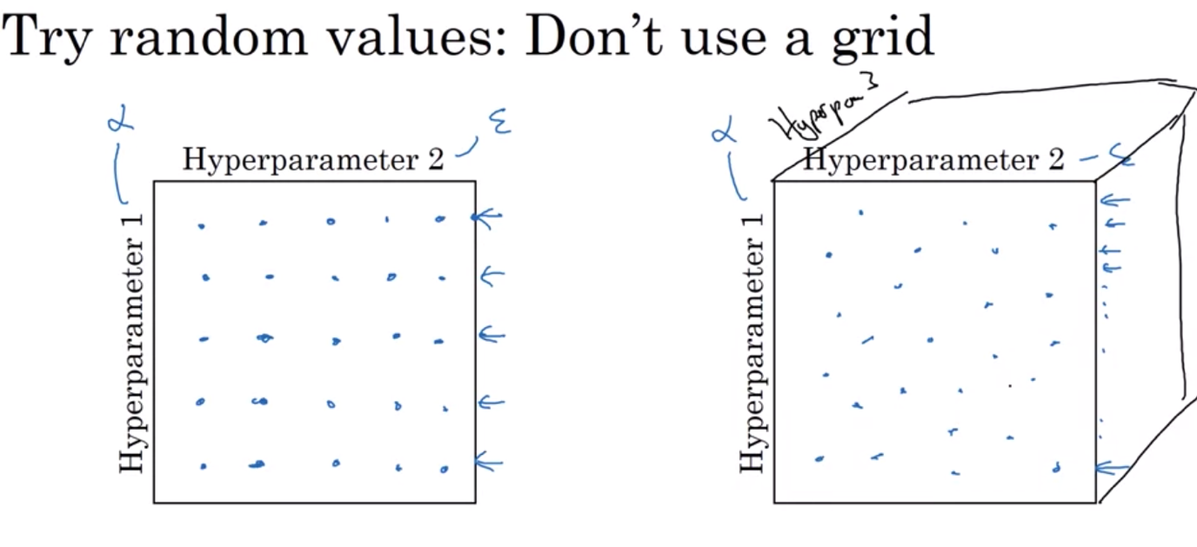

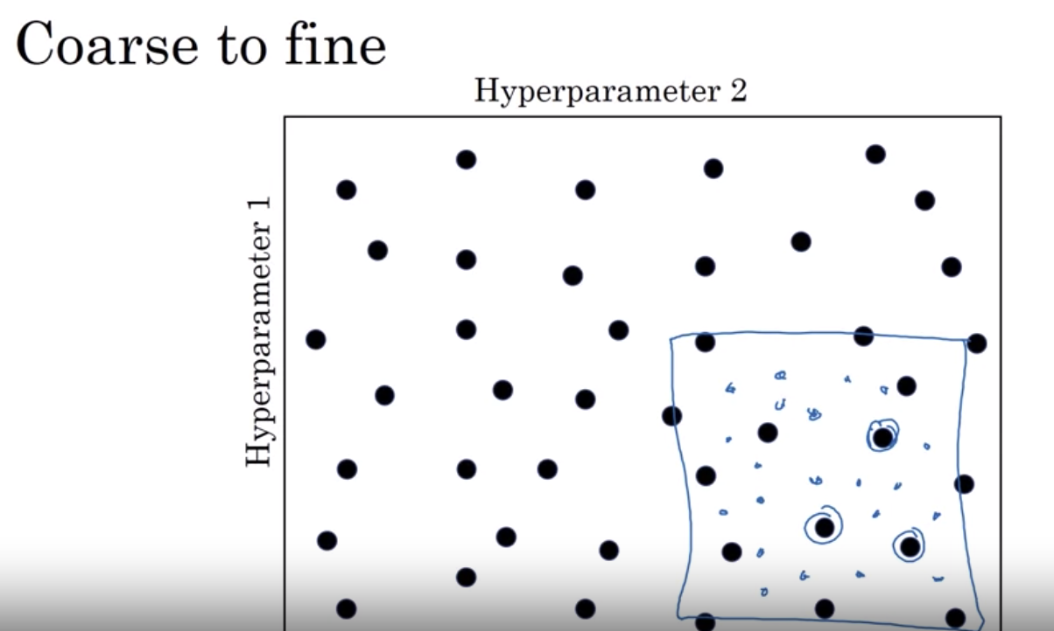

Using appropriate scale to pick hyperparameters

Could use linear scale (number of layers)/ log scale (learning rate)

For beta, use log scale: linear scale, if beta is close to 1 => very sensitive to small changes in beta

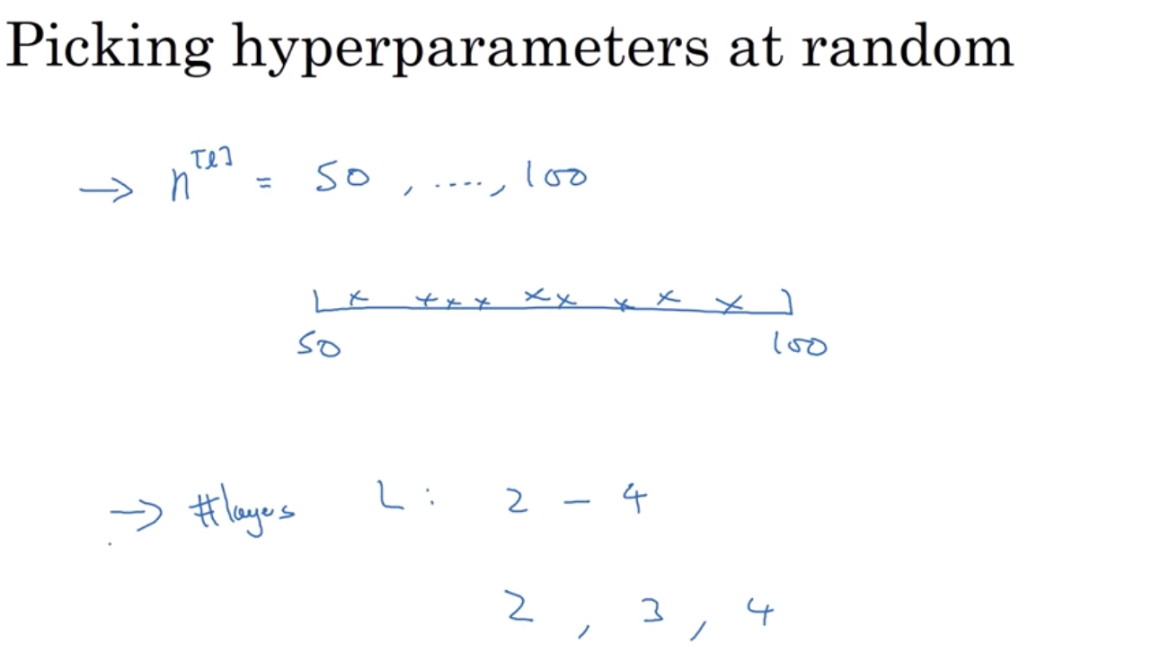

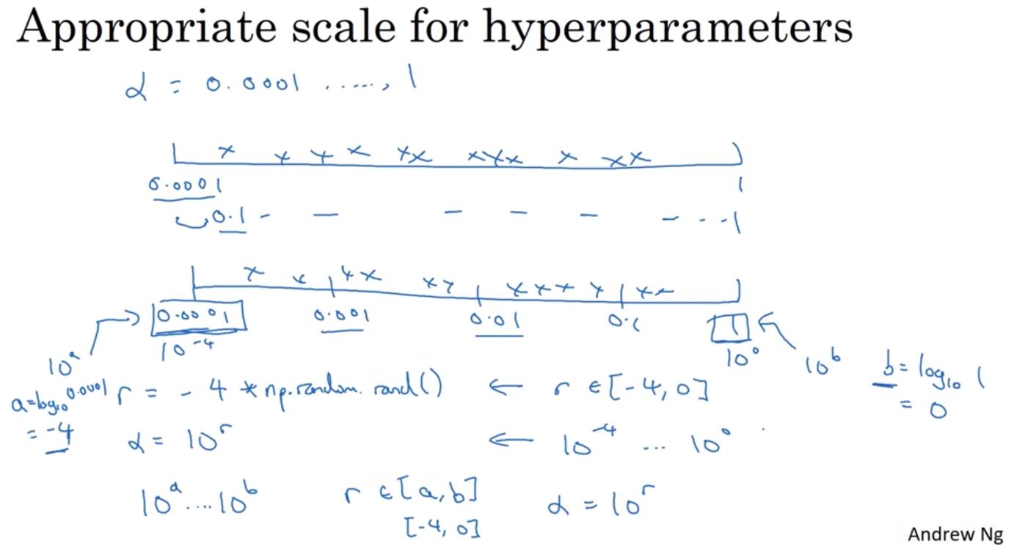

Hyperparameters tuning in practice: Pandas vs. Caviar

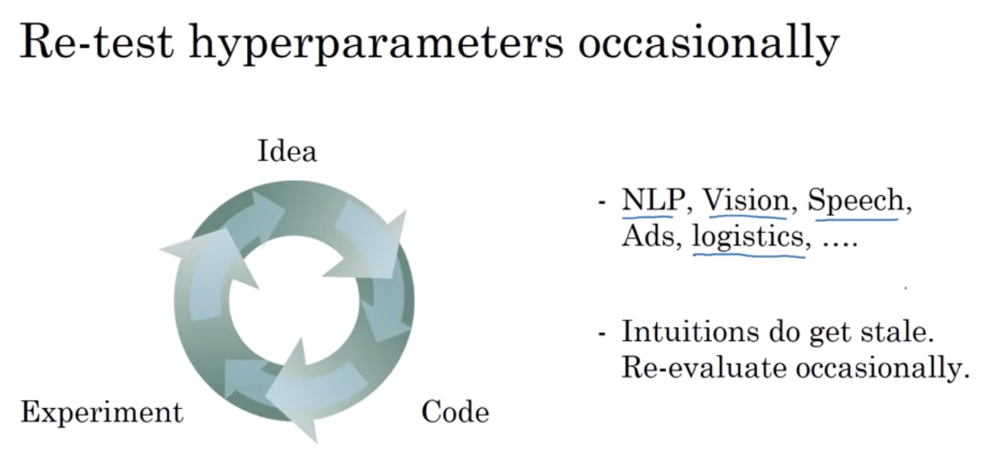

Babysitting one model: babysit the model one day at a time (esp if you don’t have the computational capacity to train large model in one sitting)

Training parallel model: run multiple models at the same time and choose the best one

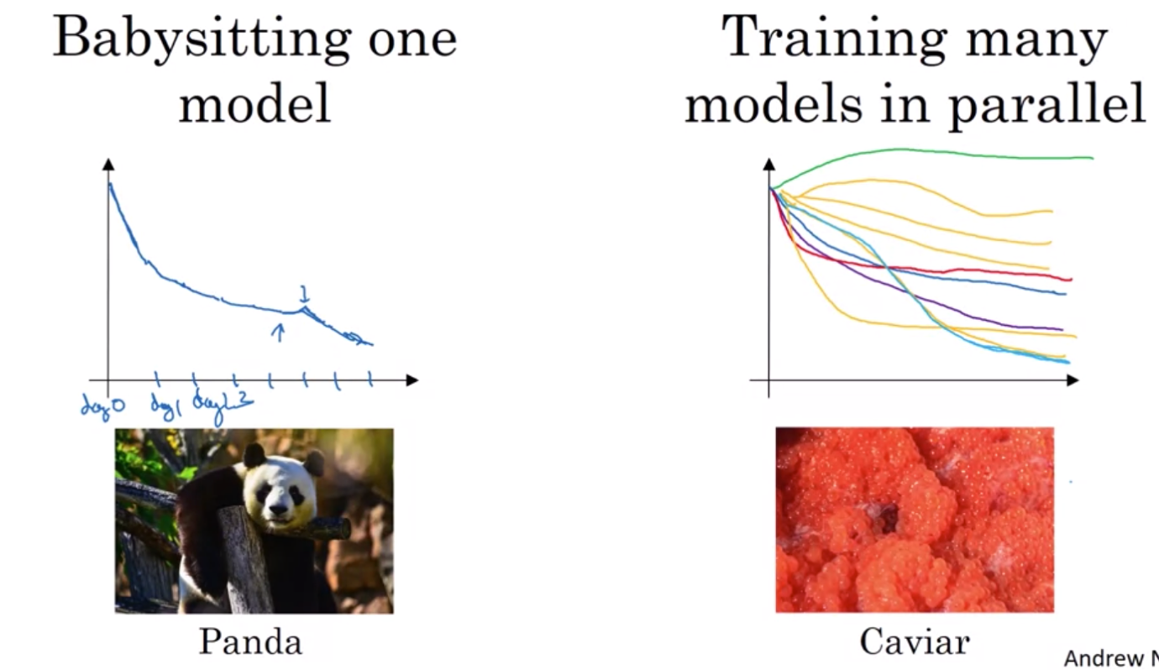

BATCH NORMALIZATION

Normalization activations in a neural network

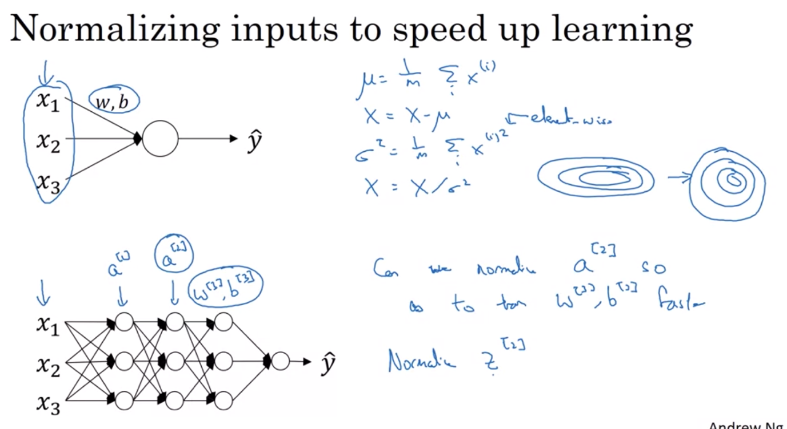

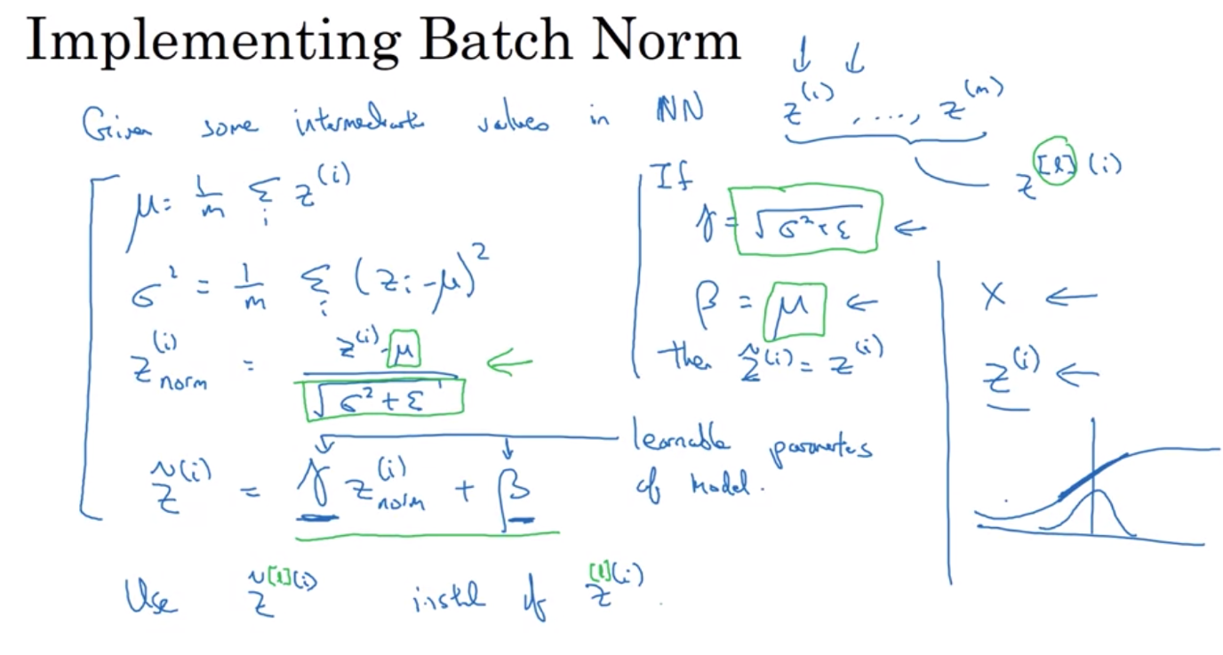

Fitting batch norm into a neural network

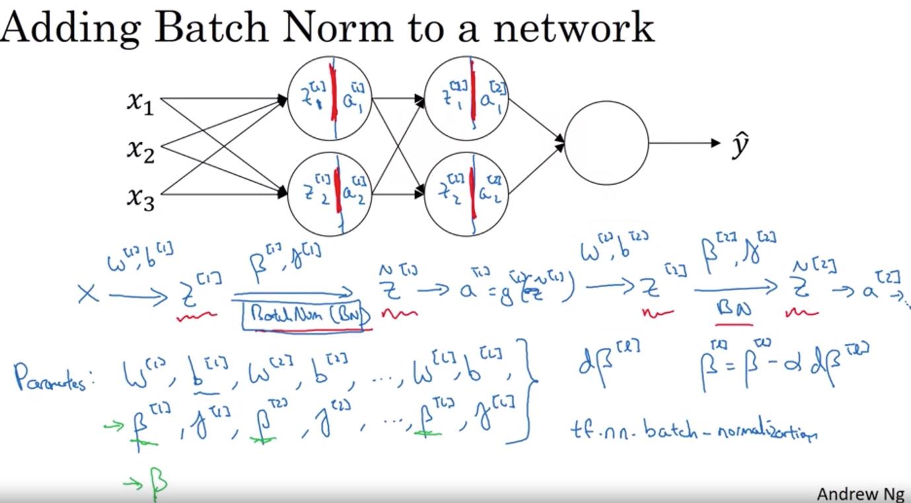

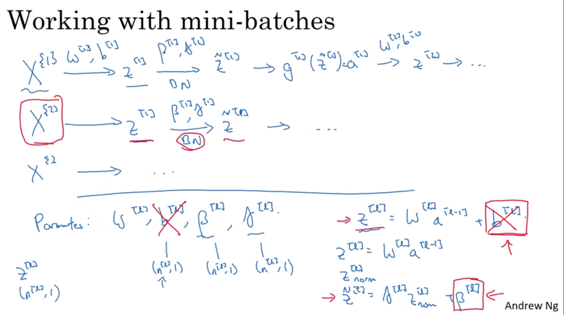

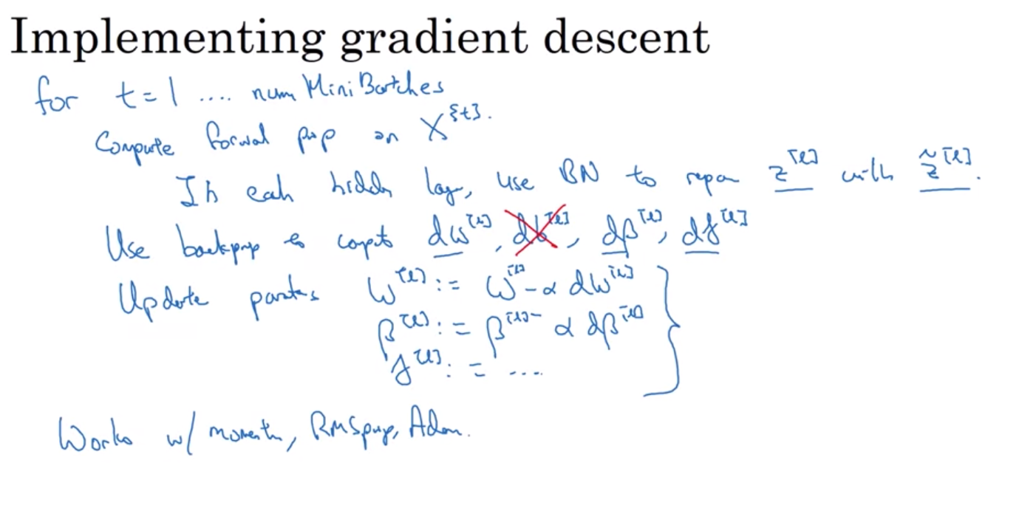

Why Batch Norm work?

It makes weights in later layers or deeper in the neural networks (layer 10) more robust to changes in the weights in earlier layers of the neural networks (layer 1).

Problem of covariate shift: ground truth function changes from training set to testing set (Ex: training on images of black and white cats but testing on colored cats).

* Problem for a large neural nets as the values in the hidden units of later layers get new constant update covariate shifts of previous layers
* Batch norm reduces the amount that the distribution of these hidden unit values shifts around
* Limits how updating the parameters can affect the distribution of values that later layers sees => reduce problem of input values changing by having them at the same mean and variance=> cause these values to become more stables so that later layers of the neural networks has more firm ground to stand on
* Allows each layer of the neural net to learn by itself, more independently of other layers
* Speed up learning of the network
* Batch norm also helps with regularization

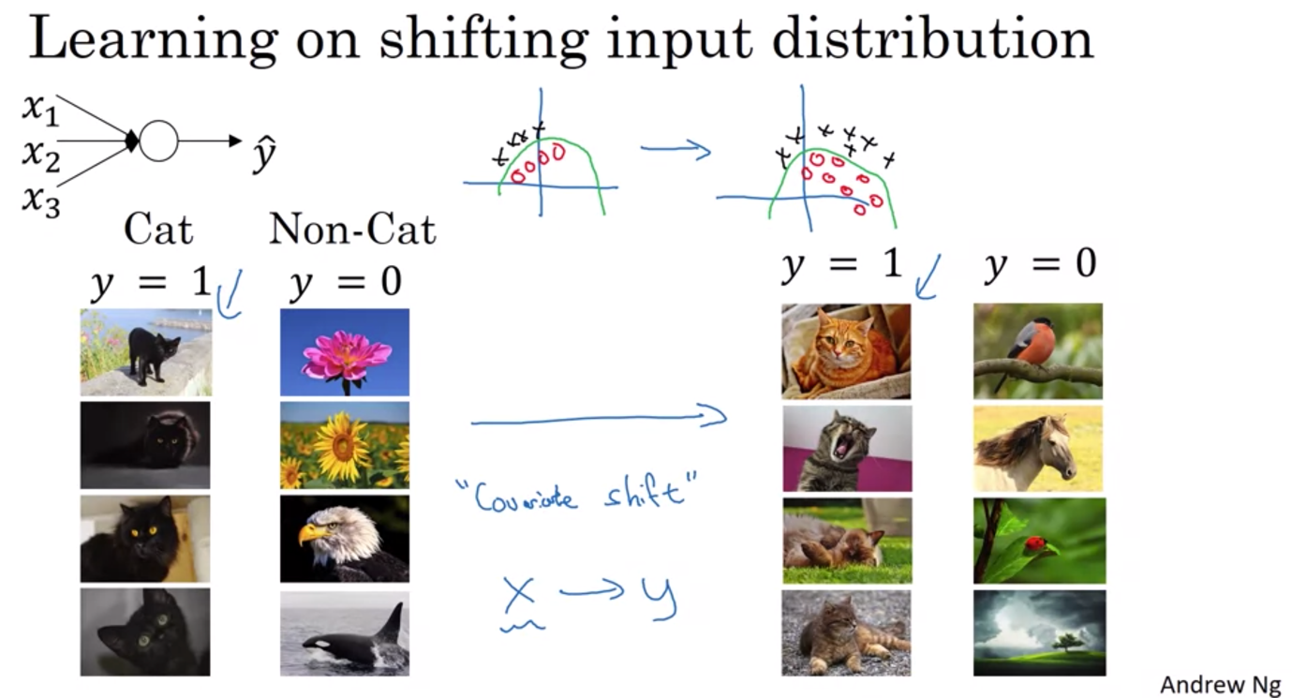

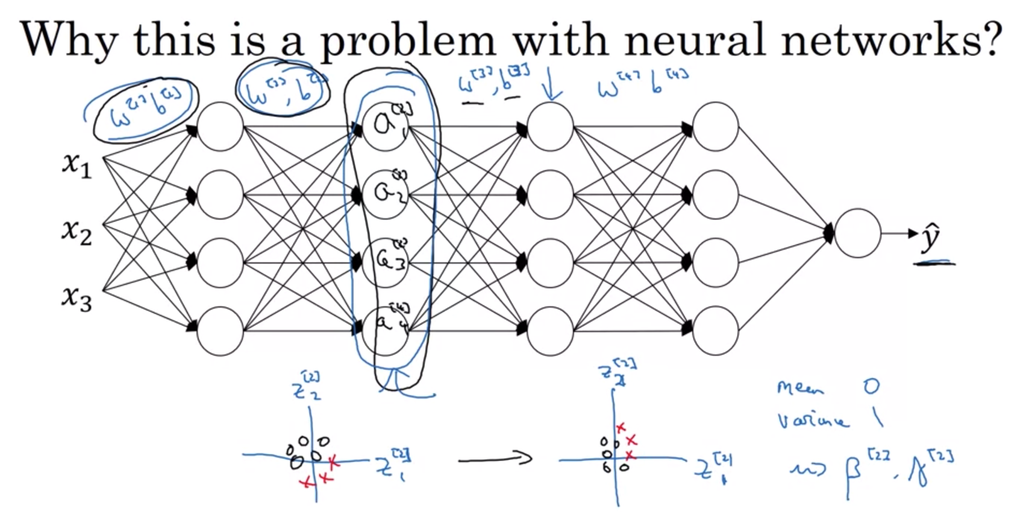

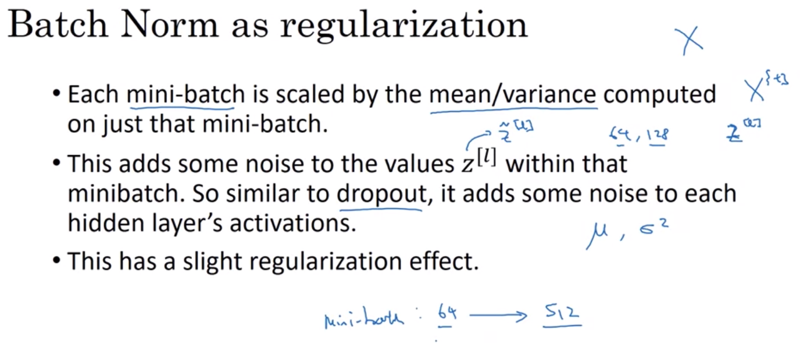

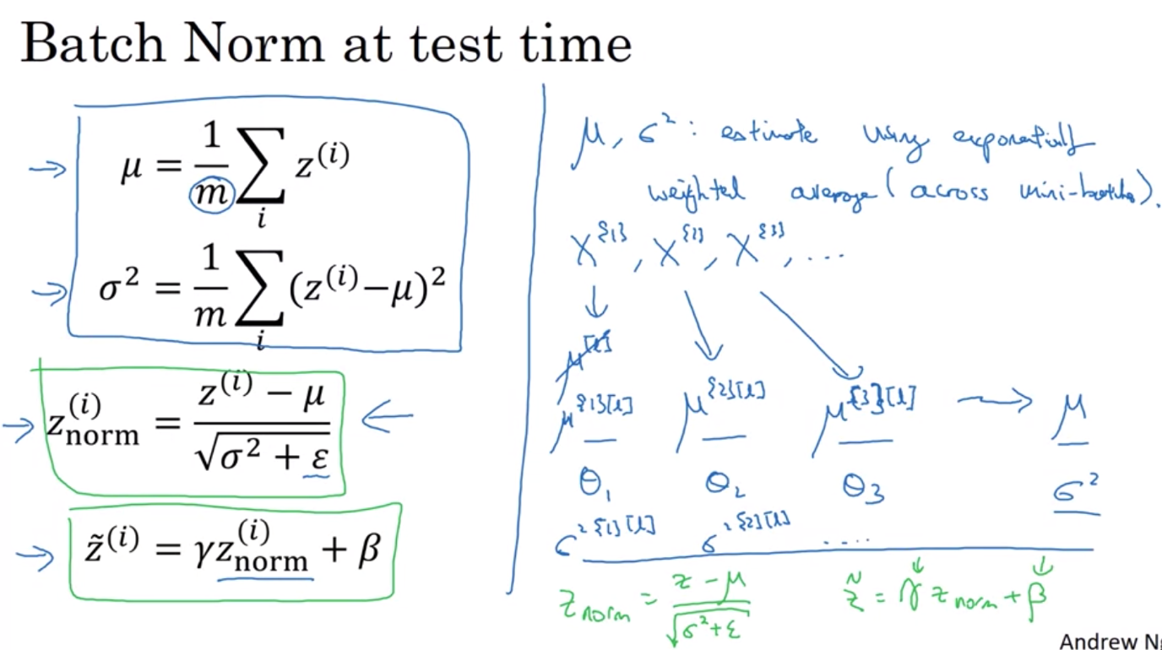

MULTI CLASS CLASSIFICATION

Softmax Regression: generalization of logistic regression

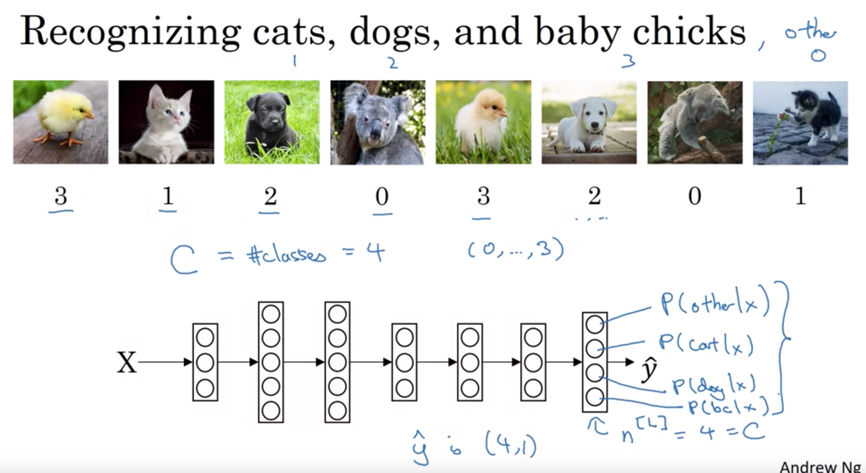

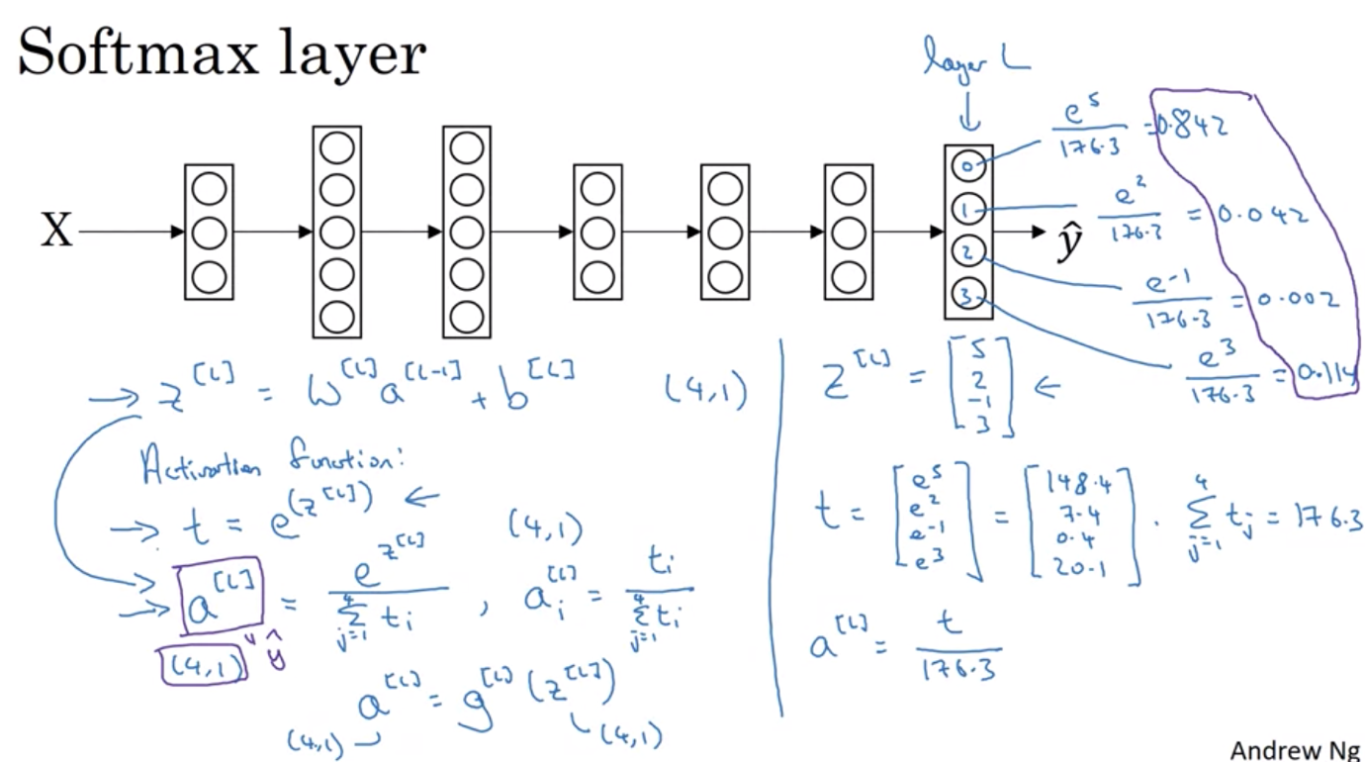

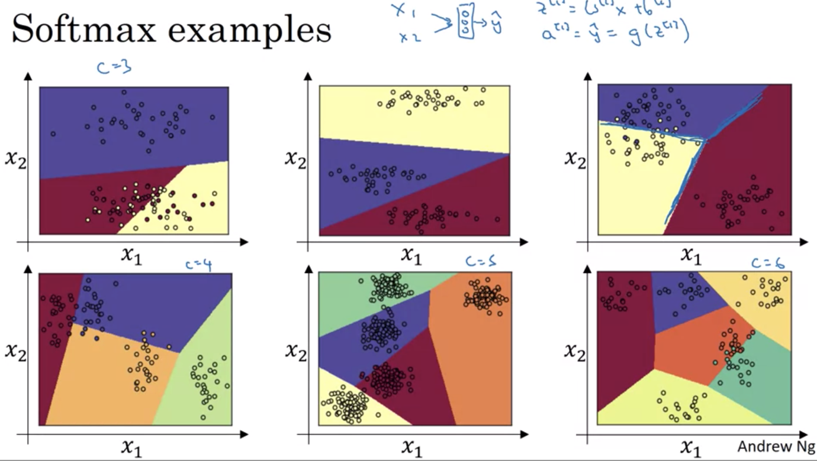

Training a softmax activation function

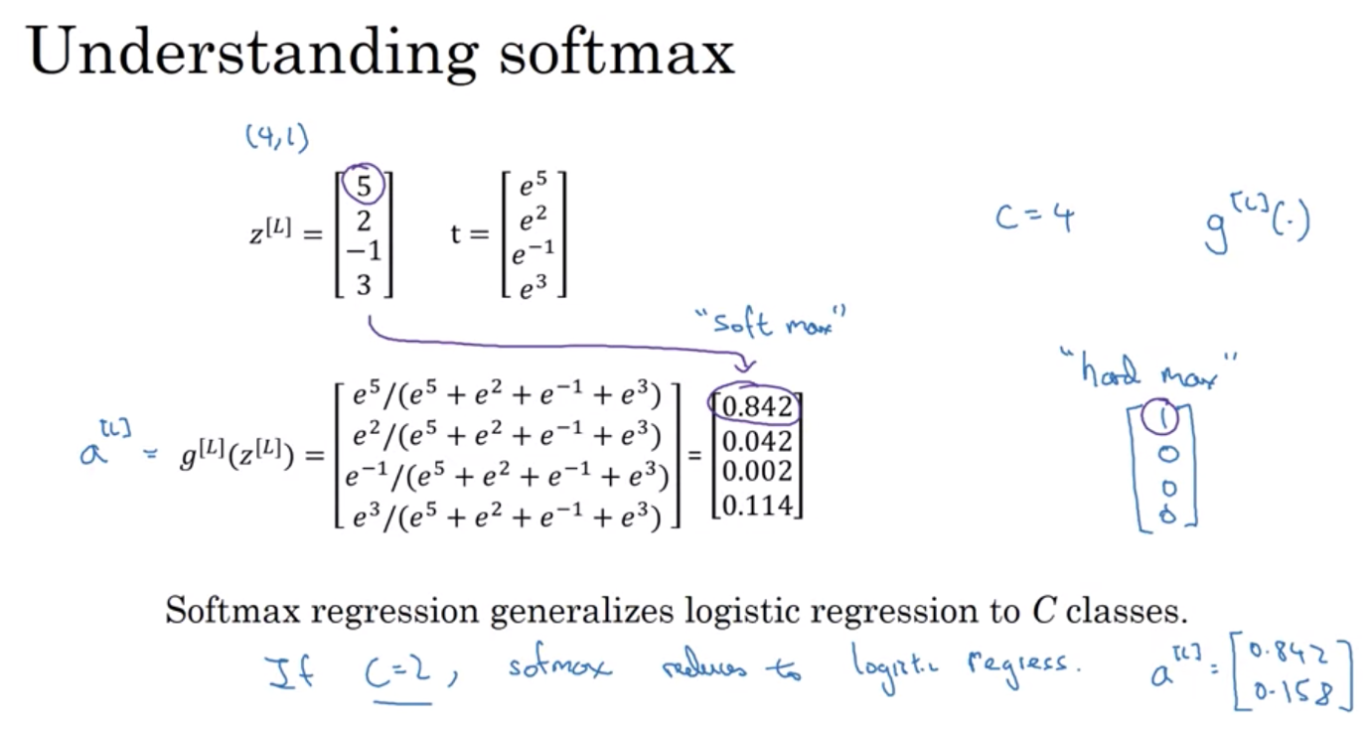

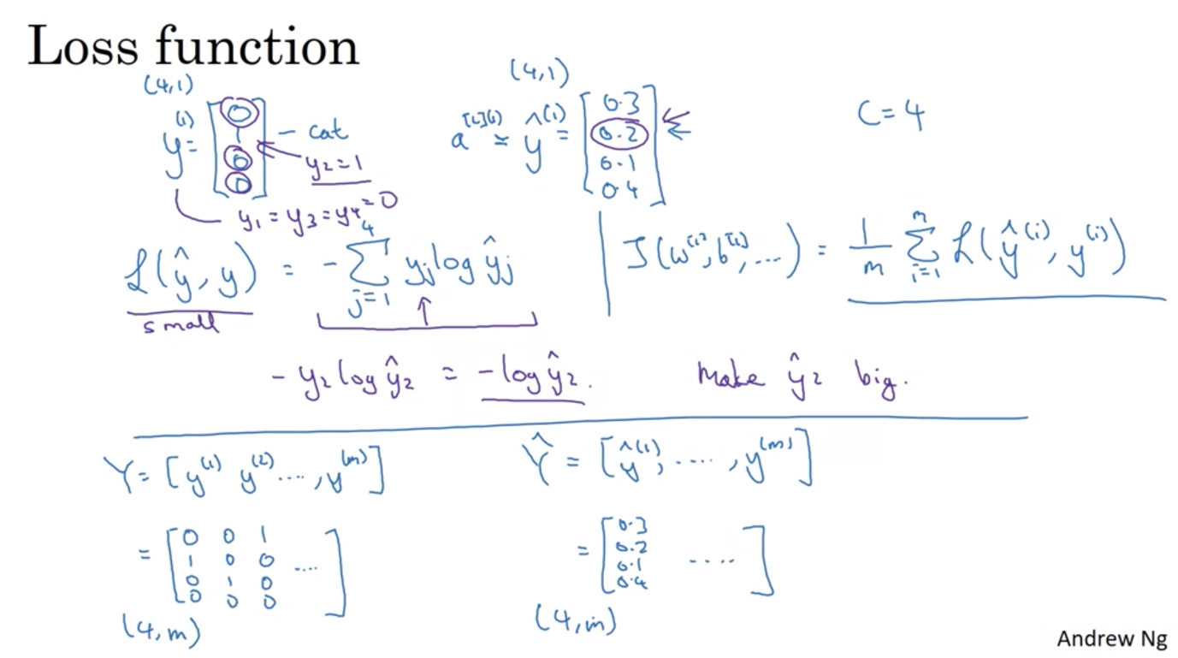

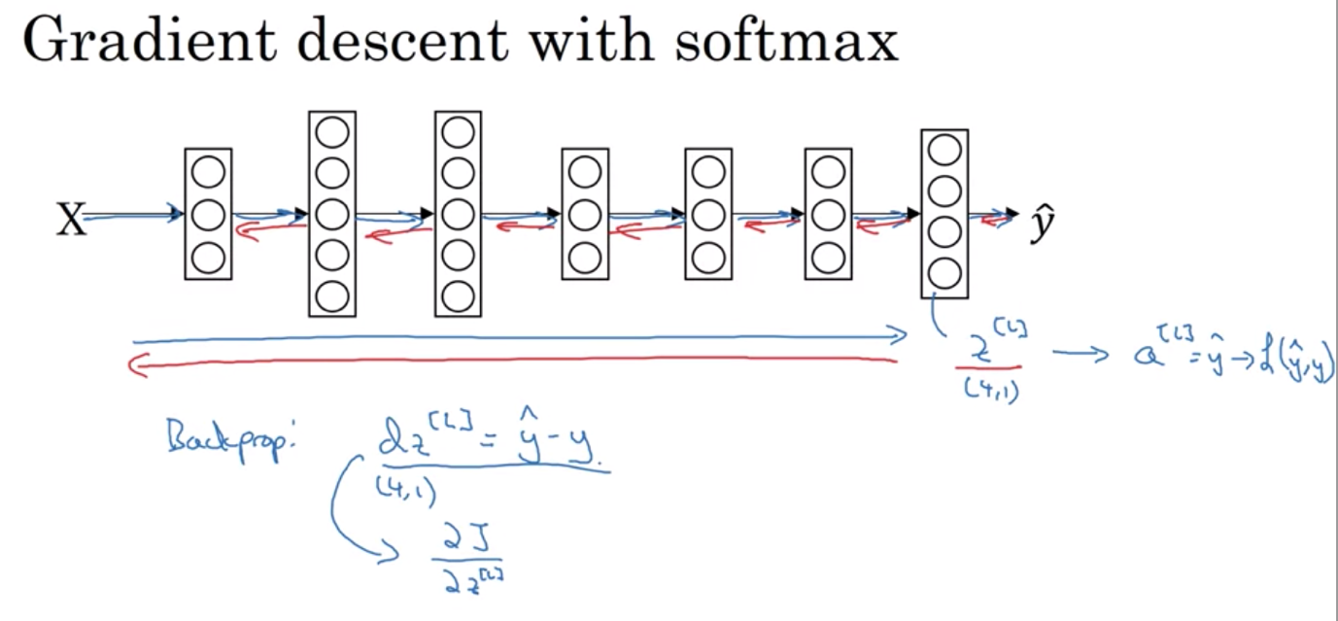

DEEP LEARNING FRAMEWORKS

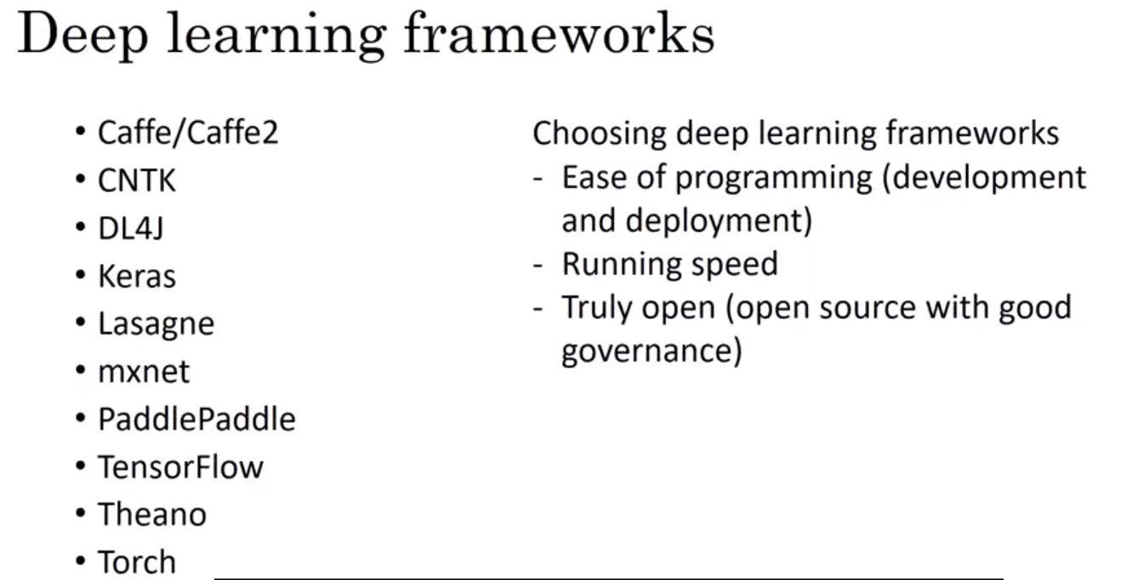

Tensorflow: find cost function problem

